Figure 7
Fixed Broadband Availability Measured by Location and Block as of December 31, 2022
(Units in thousands. Includes services of at least 100 Mbps downstream and 20 Mbps upstream)

 |  | Aggregation By Location |  | Aggregation By Block |  | Difference
Technology | Total Units | Units Covered | Ratio | Units Covered | Ratio | Difference | Ratio
Any Technology | 160,114 | 149,582 | 0.93 | 154,695 | 0.97 | 5,113 | 0.03
Satellite | 160,114 | 25,762 | 0.16 | 25,992 | 0.16 | 230 | 0.00
Terrestrial | 160,114 | 148,021 | 0.92 | 153,804 | 0.96 | 5,783 | 0.04
Fixed Wireless | 160,114 | 51,026 | 0.32 | 77,168 | 0.48 | 26,142 | 0.16
Licensed | 160,114 | 38,357 | 0.24 | 64,026 | 0.40 | 25,669 | 0.16
Unlicensed | 160,114 | 18,524 | 0.12 | 24,955 | 0.16 | 6,431 | 0.04
Wireline | 160,114 | 144,055 | 0.90 | 150,448 | 0.94 | 6,393 | 0.04
Copper Wire¹ | 160,114 | 8,685 | 0.05 | 32,296 | 0.20 | 23,610 | 0.15
Coaxial Cable | 160,114 | 135,471 | 0.85 | 141,932 | 0.89 | 6,461 | 0.04
Optical Carrier | 160,114 | 64,341 | 0.40 | 90,291 | 0.56 | 25,950 | 0.16
¹ Other is summarized with Copper Wire.
Note: The Aggregation by Location columns sum the number of units reported with terrestrial fixed broadband service of at least 100 Mbps downstream and 20 Mbps
upstream. The Aggregation by Block columns attempt to replicate the methodology used prior to the BDC where an entire block was counted as served if at least
one location in that block was reported as served. The Difference column shows the number of locations without service that would have been counted as served using
the block-level methodology. Numbers may not sum due to rounding.
Source: FCC Broadband Data Collection.
Figure 8
Availability of Fixed Broadband by Speed and Technology as of December 31, 2022

 | Share of units in Broadband Serviceable Locations with speeds of at least
Technology | 200 kbps in  at least One Direction | 10 Mbps Down  and 1 Mbps Up | 25 Mbps Down  and 3 Mbps Up | 100 Mbps Down  and 20 Mbps Up | 940 Mbps Down  and 500 Mbps Up
Any Technology | 100.0 | 100.0 | 100.0 | 93.4 | 40.0
Satellite | 100.0 | 100.0 | 100.0 | 16.1 | 0.0
Terrestrial | 99.3 | 96.9 | 95.5 | 92.4 | 40.0
Fixed Wireless | 88.7 | 67.6 | 64.6 | 31.9 | 2.2
Licensed | 85.5 | 59.1 | 55.7 | 24.0 | 0.6
Unlicensed | 25.9 | 25.3 | 23.4 | 11.6 | 1.7
Wireline | 94.4 | 92.8 | 91.2 | 90.0 | 38.5
Copper Wire¹ | 53.3 | 37.1 | 22.4 | 5.4 | 0.1
Coaxial Cable | 85.1 | 85.1 | 85.1 | 84.6 | 0.0
Optical Carrier | 40.3 | 40.2 | 40.2 | 40.2 | 38.5
¹ Other is summarized with Copper Wire.
Source: FCC Broadband Data Collection.

Figure 9
Availability of Terrestrial Fixed Broadband by State as of December 31, 2022
(Units in thousands)

 |  | At least 200 kbps in  at least One Direction |  | At least 10 Mbps Down  and 1 Mbps Up |  | At least 25 Mbps Down  and 3 Mbps Up |  | At least 100 Mbps Down  and 20 Mbps Up |  | At least 940 Mbps Down  and 500 Mbps Up
State | Units | Units | Ratio | Units | Ratio | Units | Ratio | Units | Ratio | Units | Ratio
Alabama | 2,706 | 2,662 | 0.98 | 2,422 | 0.90 | 2,346 | 0.87 | 2,228 | 0.82 | 882 | 0.33
Alaska | 381 | 345 | 0.90 | 333 | 0.87 | 308 | 0.81 | 283 | 0.74 | 12 | 0.03
American Samoa | 9 | 9 | 1.00 | 9 | 1.00 | 9 | 1.00 | 2 | 0.20 | 0 | 0.00
Arizona | 3,359 | 3,334 | 0.99 | 3,278 | 0.98 | 3,242 | 0.97 | 3,066 | 0.91 | 1,001 | 0.30
Arkansas | 1,649 | 1,621 | 0.98 | 1,500 | 0.91 | 1,442 | 0.87 | 1,318 | 0.80 | 596 | 0.36
California | 15,703 | 15,645 | 1.00 | 15,561 | 0.99 | 15,499 | 0.99 | 15,228 | 0.97 | 4,989 | 0.32
Colorado | 2,750 | 2,722 | 0.99 | 2,692 | 0.98 | 2,675 | 0.97 | 2,543 | 0.92 | 801 | 0.29
Connecticut | 1,679 | 1,676 | 1.00 | 1,661 | 0.99 | 1,659 | 0.99 | 1,649 | 0.98 | 871 | 0.52
Delaware | 510 | 510 | 1.00 | 509 | 1.00 | 509 | 1.00 | 495 | 0.97 | 241 | 0.47
District of Columbia | 366 | 366 | 1.00 | 366 | 1.00 | 366 | 1.00 | 366 | 1.00 | 203 | 0.55
Florida | 10,992 | 10,944 | 1.00 | 10,765 | 0.98 | 10,675 | 0.97 | 10,506 | 0.96 | 3,815 | 0.35
Georgia | 4,960 | 4,917 | 0.99 | 4,760 | 0.96 | 4,626 | 0.93 | 4,511 | 0.91 | 1,982 | 0.40
Guam | 38 | 37 | 1.00 | 37 | 1.00 | 37 | 1.00 | 33 | 0.87 | 3 | 0.09
Hawaii | 601 | 598 | 1.00 | 587 | 0.98 | 585 | 0.97 | 584 | 0.97 | 248 | 0.41
Idaho | 883 | 871 | 0.99 | 852 | 0.97 | 843 | 0.96 | 749 | 0.85 | 280 | 0.32
Illinois | 6,164 | 6,140 | 1.00 | 6,076 | 0.99 | 6,025 | 0.98 | 5,817 | 0.94 | 2,092 | 0.34
Indiana | 3,329 | 3,305 | 0.99 | 3,243 | 0.97 | 3,190 | 0.96 | 3,005 | 0.90 | 1,369 | 0.41
Iowa | 1,677 | 1,674 | 1.00 | 1,666 | 0.99 | 1,638 | 0.98 | 1,574 | 0.94 | 655 | 0.39
Kansas | 1,508 | 1,504 | 1.00 | 1,493 | 0.99 | 1,477 | 0.98 | 1,367 | 0.91 | 689 | 0.46
Kentucky | 2,318 | 2,287 | 0.99 | 2,187 | 0.94 | 2,064 | 0.89 | 1,975 | 0.85 | 1,123 | 0.48
Louisiana | 2,373 | 2,324 | 0.98 | 2,138 | 0.90 | 2,074 | 0.87 | 1,945 | 0.82 | 648 | 0.27
Maine | 821 | 815 | 0.99 | 794 | 0.97 | 777 | 0.95 | 721 | 0.88 | 190 | 0.23
Maryland | 2,733 | 2,725 | 1.00 | 2,697 | 0.99 | 2,689 | 0.98 | 2,657 | 0.97 | 1,510 | 0.55
Massachusetts | 3,327 | 3,325 | 1.00 | 3,313 | 1.00 | 3,312 | 1.00 | 3,300 | 0.99 | 1,325 | 0.40
Michigan | 5,192 | 5,140 | 0.99 | 4,968 | 0.96 | 4,877 | 0.94 | 4,705 | 0.91 | 1,340 | 0.26
Minnesota | 2,800 | 2,785 | 0.99 | 2,742 | 0.98 | 2,695 | 0.96 | 2,620 | 0.94 | 1,747 | 0.62
Mississippi | 1,587 | 1,545 | 0.97 | 1,376 | 0.87 | 1,290 | 0.81 | 1,239 | 0.78 | 686 | 0.43
Missouri | 3,146 | 3,122 | 0.99 | 3,039 | 0.97 | 2,991 | 0.95 | 2,802 | 0.89 | 1,611 | 0.51
Montana | 621 | 600 | 0.97 | 563 | 0.91 | 539 | 0.87 | 461 | 0.74 | 106 | 0.17
Nebraska | 1,003 | 994 | 0.99 | 983 | 0.98 | 968 | 0.97 | 931 | 0.93 | 538 | 0.54

Figure 9 - Continued
Availability of Terrestrial Fixed Broadband by State as of December 31, 2022
(Units in thousands)

 |  | At least 200 kbps in  at least One Direction |  | At least 10 Mbps Down  and 1 Mbps Up |  | At least 25 Mbps Down  and 3 Mbps Up |  | At least 100 Mbps Down  and 20 Mbps Up |  | At least 940 Mbps Down  and 500 Mbps Up
State | Units | Units | Ratio | Units | Ratio | Units | Ratio | Units | Ratio | Units | Ratio
Nevada | 1,401 | 1,397 | 1.00 | 1,389 | 0.99 | 1,385 | 0.99 | 1,362 | 0.97 | 327 | 0.23
New Hampshire | 718 | 716 | 1.00 | 695 | 0.97 | 689 | 0.96 | 678 | 0.94 | 338 | 0.47
New Jersey | 4,249 | 4,241 | 1.00 | 4,173 | 0.98 | 4,171 | 0.98 | 4,109 | 0.97 | 2,424 | 0.57
New Mexico | 1,074 | 1,060 | 0.99 | 1,006 | 0.94 | 981 | 0.91 | 877 | 0.82 | 143 | 0.13
New York | 9,235 | 9,190 | 1.00 | 9,061 | 0.98 | 9,042 | 0.98 | 8,970 | 0.97 | 5,692 | 0.62
North Carolina | 5,393 | 5,348 | 0.99 | 5,159 | 0.96 | 5,024 | 0.93 | 4,849 | 0.90 | 1,768 | 0.33
North Dakota | 484 | 483 | 1.00 | 478 | 0.99 | 477 | 0.99 | 474 | 0.98 | 279 | 0.58
Northern Mariana Isl | 11 | 10 | 0.98 | 10 | 0.98 | 10 | 0.98 | 5 | 0.45 | 2 | 0.18
Ohio | 5,903 | 5,875 | 1.00 | 5,807 | 0.98 | 5,752 | 0.97 | 5,587 | 0.95 | 1,984 | 0.34
Oklahoma | 2,057 | 2,043 | 0.99 | 1,998 | 0.97 | 1,946 | 0.95 | 1,802 | 0.88 | 789 | 0.38
Oregon | 2,015 | 1,994 | 0.99 | 1,953 | 0.97 | 1,906 | 0.95 | 1,835 | 0.91 | 763 | 0.38
Pennsylvania | 6,404 | 6,360 | 0.99 | 6,163 | 0.96 | 6,110 | 0.95 | 6,045 | 0.94 | 2,966 | 0.46
Puerto Rico | 1,613 | 1,610 | 1.00 | 1,605 | 0.99 | 1,602 | 0.99 | 1,568 | 0.97 | 794 | 0.49
Rhode Island | 534 | 534 | 1.00 | 531 | 0.99 | 531 | 0.99 | 530 | 0.99 | 406 | 0.76
South Carolina | 2,714 | 2,694 | 0.99 | 2,609 | 0.96 | 2,574 | 0.95 | 2,478 | 0.91 | 914 | 0.34
South Dakota | 511 | 509 | 1.00 | 495 | 0.97 | 487 | 0.95 | 468 | 0.91 | 129 | 0.25
Tennessee | 3,423 | 3,388 | 0.99 | 3,306 | 0.97 | 3,240 | 0.95 | 3,161 | 0.92 | 1,788 | 0.52
Texas | 13,314 | 13,244 | 0.99 | 12,901 | 0.97 | 12,769 | 0.96 | 12,260 | 0.92 | 6,104 | 0.46
Utah | 1,324 | 1,319 | 1.00 | 1,309 | 0.99 | 1,298 | 0.98 | 1,269 | 0.96 | 715 | 0.54
Vermont | 372 | 372 | 1.00 | 349 | 0.94 | 337 | 0.91 | 303 | 0.82 | 135 | 0.36
Virgin Islands | 33 | 33 | 0.99 | 33 | 0.99 | 33 | 0.99 | 33 | 0.99 | 0 | 0.00
Virginia | 4,096 | 4,035 | 0.99 | 3,879 | 0.95 | 3,824 | 0.93 | 3,747 | 0.91 | 1,863 | 0.45
Washington | 3,515 | 3,488 | 0.99 | 3,411 | 0.97 | 3,323 | 0.95 | 3,186 | 0.91 | 987 | 0.28
West Virginia | 1,039 | 978 | 0.94 | 884 | 0.85 | 774 | 0.75 | 704 | 0.68 | 165 | 0.16
Wisconsin | 3,177 | 3,149 | 0.99 | 3,066 | 0.97 | 2,968 | 0.93 | 2,764 | 0.87 | 968 | 0.30
Wyoming | 320 | 313 | 0.98 | 305 | 0.95 | 300 | 0.94 | 276 | 0.86 | 62 | 0.19
Total | 160,114 | 158,925 | 0.99 | 155,184 | 0.97 | 152,980 | 0.96 | 148,021 | 0.92 | 64,059 | 0.40
# = Rounds to Zero.
Note: Satellite services are excluded from this analysis. Numbers may not sum to totals due to rounding.
Source: FCC Broadband Data Collection.

Figure 10
Availability of Mobile Broadband by State as of December 31, 2022
(Units in thousands)

 |  | At least 3G  (200 Kbps Down  and 50 Kbps Up) |  | At least 4G LTE  (5 Mbps Down  and 1 Mbps Up) |  | At least 5G-NR  (7 Mbps Down  and 1 Mbps Up) |  | At least 5G-NR  (35 Mbps Down  and 3 Mbps Up)
State | Units | Units | Ratio | Units | Ratio | Units | Ratio | Units | Ratio
Alabama | 2,706 | 2,696 | 1.00 | 2,696 | 1.00 | 2,558 | 0.95 | 2,250 | 0.83
Alaska | 381 | 365 | 0.96 | 352 | 0.92 | 293 | 0.77 | 228 | 0.60
American Samoa | 9 | 9 | 1.00 | 9 | 0.99 | 0 | 0.00 | 0 | 0.00
Arizona | 3,359 | 3,351 | 1.00 | 3,350 | 1.00 | 3,267 | 0.97 | 3,216 | 0.96
Arkansas | 1,649 | 1,624 | 0.98 | 1,624 | 0.98 | 1,522 | 0.92 | 1,302 | 0.79
California | 15,703 | 15,638 | 1.00 | 15,637 | 1.00 | 15,530 | 0.99 | 15,271 | 0.97
Colorado | 2,750 | 2,727 | 0.99 | 2,724 | 0.99 | 2,624 | 0.95 | 2,516 | 0.91
Connecticut | 1,679 | 1,672 | 1.00 | 1,672 | 1.00 | 1,639 | 0.98 | 1,506 | 0.90
Delaware | 510 | 507 | 0.99 | 507 | 0.99 | 505 | 0.99 | 482 | 0.94
District of Columbia | 366 | 366 | 1.00 | 366 | 1.00 | 366 | 1.00 | 366 | 1.00
Florida | 10,992 | 10,910 | 0.99 | 10,910 | 0.99 | 10,849 | 0.99 | 10,442 | 0.95
Georgia | 4,960 | 4,947 | 1.00 | 4,947 | 1.00 | 4,731 | 0.95 | 4,290 | 0.86
Guam | 38 | 37 | 0.99 | 37 | 0.99 | 21 | 0.56 | 16 | 0.44
Hawaii | 601 | 592 | 0.98 | 592 | 0.98 | 584 | 0.97 | 557 | 0.93
Idaho | 883 | 868 | 0.98 | 868 | 0.98 | 829 | 0.94 | 745 | 0.84
Illinois | 6,164 | 6,158 | 1.00 | 6,158 | 1.00 | 6,056 | 0.98 | 5,724 | 0.93
Indiana | 3,329 | 3,324 | 1.00 | 3,324 | 1.00 | 3,251 | 0.98 | 2,915 | 0.88
Iowa | 1,677 | 1,673 | 1.00 | 1,672 | 1.00 | 1,537 | 0.92 | 1,313 | 0.78
Kansas | 1,508 | 1,507 | 1.00 | 1,507 | 1.00 | 1,416 | 0.94 | 1,284 | 0.85
Kentucky | 2,318 | 2,260 | 0.98 | 2,255 | 0.97 | 1,988 | 0.86 | 1,681 | 0.73
Louisiana | 2,373 | 2,369 | 1.00 | 2,369 | 1.00 | 2,295 | 0.97 | 2,049 | 0.86
Maine | 821 | 796 | 0.97 | 796 | 0.97 | 705 | 0.86 | 508 | 0.62
Maryland | 2,733 | 2,713 | 0.99 | 2,713 | 0.99 | 2,699 | 0.99 | 2,568 | 0.94
Massachusetts | 3,327 | 3,305 | 0.99 | 3,305 | 0.99 | 3,263 | 0.98 | 3,057 | 0.92
Michigan | 5,192 | 5,151 | 0.99 | 5,151 | 0.99 | 4,960 | 0.96 | 4,437 | 0.85
Minnesota | 2,800 | 2,787 | 1.00 | 2,787 | 1.00 | 2,690 | 0.96 | 2,386 | 0.85
Mississippi | 1,587 | 1,584 | 1.00 | 1,580 | 1.00 | 1,355 | 0.85 | 1,089 | 0.69
Missouri | 3,146 | 3,130 | 0.99 | 3,130 | 0.99 | 3,030 | 0.96 | 2,742 | 0.87
Montana | 621 | 600 | 0.97 | 599 | 0.96 | 560 | 0.90 | 487 | 0.78
Nebraska | 1,003 | 1,001 | 1.00 | 1,000 | 1.00 | 737 | 0.73 | 672 | 0.67

Figure 10 - Continued
Availability of Mobile Broadband by State as of December 31, 2022
(Units in thousands)

 |  | At least 3G  (200 Kbps Down  and 50 Kbps Up) |  | At least 4G LTE  (5 Mbps Down  and 1 Mbps Up) |  | At least 5G-NR  (7 Mbps Down  and 1 Mbps Up) |  | At least 5G-NR  (35 Mbps Down  and 3 Mbps Up)
State | Units | Units | Ratio | Units | Ratio | Units | Ratio | Units | Ratio
Nevada | 1,401 | 1,400 | 1.00 | 1,399 | 1.00 | 1,391 | 0.99 | 1,376 | 0.98
New Hampshire | 718 | 715 | 0.99 | 715 | 0.99 | 611 | 0.85 | 471 | 0.66
New Jersey | 4,249 | 4,232 | 1.00 | 4,232 | 1.00 | 4,218 | 0.99 | 4,116 | 0.97
New Mexico | 1,074 | 1,061 | 0.99 | 1,058 | 0.98 | 1,019 | 0.95 | 933 | 0.87
New York | 9,235 | 9,167 | 0.99 | 9,167 | 0.99 | 8,968 | 0.97 | 8,551 | 0.93
North Carolina | 5,393 | 5,344 | 0.99 | 5,335 | 0.99 | 5,065 | 0.94 | 4,523 | 0.84
North Dakota | 484 | 482 | 1.00 | 482 | 1.00 | 447 | 0.92 | 360 | 0.74
Northern Mariana Isl | 11 | 10 | 0.99 | 10 | 0.98 | # | 0.01 | # | 0.00
Ohio | 5,903 | 5,866 | 0.99 | 5,866 | 0.99 | 5,780 | 0.98 | 5,384 | 0.91
Oklahoma | 2,057 | 2,053 | 1.00 | 2,052 | 1.00 | 1,985 | 0.97 | 1,806 | 0.88
Oregon | 2,015 | 1,987 | 0.99 | 1,987 | 0.99 | 1,918 | 0.95 | 1,793 | 0.89
Pennsylvania | 6,404 | 6,351 | 0.99 | 6,351 | 0.99 | 6,186 | 0.97 | 5,785 | 0.90
Puerto Rico | 1,613 | 1,611 | 1.00 | 1,610 | 1.00 | 1,607 | 1.00 | 1,605 | 0.99
Rhode Island | 534 | 530 | 0.99 | 530 | 0.99 | 527 | 0.99 | 487 | 0.91
South Carolina | 2,714 | 2,705 | 1.00 | 2,705 | 1.00 | 2,579 | 0.95 | 2,327 | 0.86
South Dakota | 511 | 506 | 0.99 | 506 | 0.99 | 481 | 0.94 | 413 | 0.81
Tennessee | 3,423 | 3,378 | 0.99 | 3,378 | 0.99 | 3,187 | 0.93 | 2,859 | 0.84
Texas | 13,314 | 13,290 | 1.00 | 13,288 | 1.00 | 13,095 | 0.98 | 12,380 | 0.93
Utah | 1,324 | 1,319 | 1.00 | 1,319 | 1.00 | 1,311 | 0.99 | 1,289 | 0.97
Vermont | 372 | 358 | 0.96 | 358 | 0.96 | 262 | 0.70 | 191 | 0.51
Virgin Islands | 33 | 33 | 1.00 | 33 | 1.00 | 31 | 0.95 | 31 | 0.95
Virginia | 4,096 | 4,043 | 0.99 | 4,043 | 0.99 | 3,825 | 0.93 | 3,426 | 0.84
Washington | 3,515 | 3,472 | 0.99 | 3,472 | 0.99 | 3,393 | 0.97 | 3,179 | 0.90
West Virginia | 1,039 | 915 | 0.88 | 915 | 0.88 | 822 | 0.79 | 660 | 0.64
Wisconsin | 3,177 | 3,145 | 0.99 | 3,144 | 0.99 | 2,854 | 0.90 | 2,485 | 0.78
Wyoming | 320 | 316 | 0.99 | 315 | 0.98 | 273 | 0.85 | 224 | 0.70
Total | 160,114 | 158,959 | 0.99 | 158,909 | 0.99 | 153,698 | 0.96 | 142,753 | 0.89
# = Rounds to Zero.
Note: Numbers may not sum to totals due to rounding.
Source: FCC Broadband Data Collection.

Figure 11
Connections over 200 kbps in at Least One Direction 2018-2022
(in thousands)

 | 2018 | 2019 |  | 2020 |  | 2021 |  | 2022
Technology | Dec | Jun | Dec | Jun | Dec | Jun | Dec | Jun | Dec
Total | 451,060 | 459,350 | 466,320 | 480,200 | 490,890 | 500,260 | 510,200 | 518,230 | 527,297
Mobile | 340,280 | 346,600 | 352,010 | 361,740 | 369,640 | 376,840 | 384,420 | 391,876 | 399,258
Fixed | 110,780 | 112,740 | 114,310 | 118,460 | 121,250 | 123,430 | 125,780 | 126,354 | 128,038
Note: Some previously-published data may have been revised. Numbers may not sum to totals due to rounding.
Source: FCC Form 477.

Figure 12
Residential Connections over 200 kbps in at Least One Direction 2018-2022
(in thousands)

 | 2018 | 2019 |  | 2020 |  | 2021 |  | 2022
Technology | Dec | Jun | Dec | Jun | Dec | Jun | Dec | Jun | Dec
Total | 378,290 | 383,620 | 388,360 | 403,230 | 407,650 | 415,260 | 436,580 | 442,439 | 448,601
Mobile | 276,940 | 280,490 | 283,640 | 294,300 | 296,030 | 301,680 | 320,780 | 325,832 | 330,065
Fixed | 101,350 | 103,130 | 104,720 | 108,920 | 111,620 | 113,580 | 115,790 | 116,608 | 118,536
Note: Some previously-published data may have been revised. Numbers may not sum to totals due to rounding.
Source: FCC Form 477.

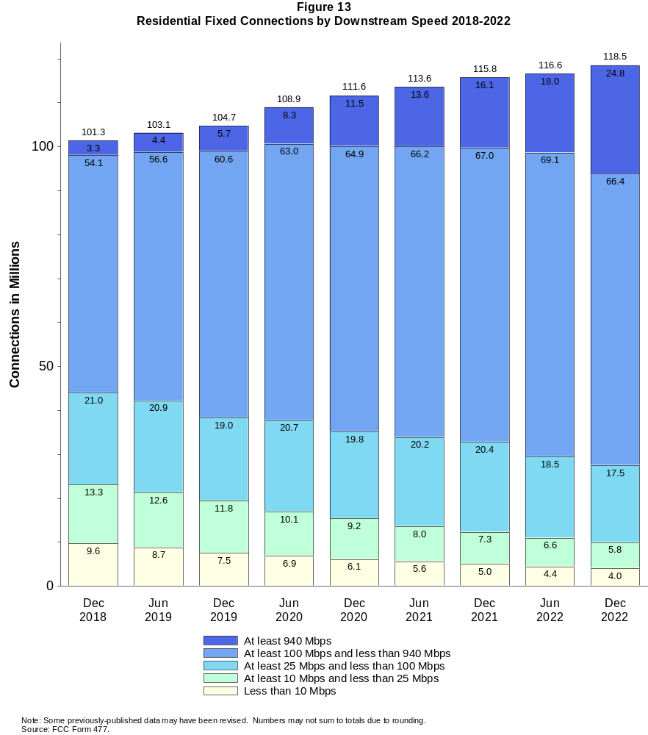

Figure 14
Distribution of Fixed Connections over 200 kbps in at Least One Direction as of December 31, 2022

 | Downstream Speed
Upstream Speed | Less than 10 Mbps | At least 10 Mbps  and less than 25 Mbps | At least 25 Mbps  and less than 100 Mbps | At least 100 Mbps  and less than 940 Mbps | At least 940 Mbps | Total
Less than 1 Mbps | 3,061 | 672 | # | 0 | # | 3,733
At least 1 Mbps & Less than 3 Mbps | 1,512 | 4,292 | 559 | 1 | # | 6,364
At least 3 Mbps & Less than 20 Mbps | 129 | 1,563 | 16,345 | 36,791 | 1,804 | 56,632
At least 20 Mbps & Less than 500 Mbps | # | 60 | 2,854 | 31,339 | 12,663 | 46,916
At least 500 Mbps | 0 | # | 1 | 3,167 | 11,225 | 14,393
Total | 4,702 | 6,587 | 19,759 | 71,298 | 25,692 | 128,038

Percentages

Less than 1 Mbps | 2.4 | 0.5 | 0.0 | 0.0 | 0.0 | 2.9
At least 1 Mbps & Less than 3 Mbps | 1.2 | 3.4 | 0.4 | 0.0 | 0.0 | 5.0
At least 3 Mbps & Less than 20 Mbps | 0.1 | 1.2 | 12.8 | 28.7 | 1.4 | 44.2
At least 20 Mbps & Less than 500 Mbps | 0.0 | 0.0 | 2.2 | 24.5 | 9.9 | 36.6
At least 500 Mbps | 0.0 | 0.0 | 0.0 | 2.5 | 8.8 | 11.2
Total | 3.7 | 5.1 | 15.4 | 55.7 | 20.1 | 100.0
# = Rounds to zero.
Note: Numbers may not sum to totals due to rounding.
Source: FCC Form 477.

Figure 15
Distribution of Residential Fixed Connections over 200 kbps in at Least One Direction as of December 31, 2022

 | Downstream Speed
Upstream Speed | Less than 10 Mbps | At least 10 Mbps  and less than 25 Mbps | At least 25 Mbps  and less than 100 Mbps | At least 100 Mbps  and less than 940 Mbps | At least 940 Mbps | Total
Less than 1 Mbps | 2,578 | 626 | # | 0 | # | 3,204
At least 1 Mbps & Less than 3 Mbps | 1,343 | 3,819 | 508 | 1 | # | 5,671
At least 3 Mbps & Less than 20 Mbps | 103 | 1,381 | 14,589 | 34,854 | 1,803 | 52,730
At least 20 Mbps & Less than 500 Mbps | # | 24 | 2,436 | 28,443 | 12,270 | 43,174
At least 500 Mbps | 0 | # | 1 | 3,057 | 10,700 | 13,758
Total | 4,024 | 5,850 | 17,534 | 66,355 | 24,774 | 118,536

Percentages

Less than 1 Mbps | 2.2 | 0.5 | 0.0 | 0.0 | 0.0 | 2.7
At least 1 Mbps & Less than 3 Mbps | 1.1 | 3.2 | 0.4 | 0.0 | 0.0 | 4.8
At least 3 Mbps & Less than 20 Mbps | 0.1 | 1.2 | 12.3 | 29.4 | 1.5 | 44.5
At least 20 Mbps & Less than 500 Mbps | 0.0 | 0.0 | 2.1 | 24.0 | 10.4 | 36.4
At least 500 Mbps | 0.0 | 0.0 | 0.0 | 2.6 | 9.0 | 11.6
Total | 3.4 | 4.9 | 14.8 | 56.0 | 20.9 | 100.0
# = Rounds to zero.
Note: Numbers may not sum to totals due to rounding.
Source: FCC Form 477.

Figure 16
Connections over 200 kbps in at Least One Direction by Technology 2018-2022
(in thousands)

 | 2018 | 2019 |  | 2020 |  | 2021 |  | 2022
Technology | Dec | Jun | Dec | Jun | Dec | Jun | Dec | Jun | Dec
Total | 451,060 | 459,350 | 466,320 | 480,200 | 490,890 | 500,260 | 510,200 | 518,230 | 527,297
Mobile | 340,280 | 346,600 | 352,010 | 361,740 | 369,640 | 376,840 | 384,420 | 391,876 | 399,258
Fixed | 110,780 | 112,740 | 114,310 | 118,460 | 121,250 | 123,430 | 125,780 | 126,354 | 128,038
Copper Wire¹ | 22,953 | 21,681 | 20,755 | 20,174 | 19,327 | 18,620 | 17,412 | 15,644 | 14,712
Coaxial Cable | 68,882 | 70,750 | 72,516 | 75,986 | 77,909 | 79,330 | 80,232 | 80,022 | 80,110
Optical Carrier | 15,492 | 16,748 | 17,376 | 18,459 | 19,945 | 21,120 | 23,338 | 24,984 | 26,343
Satellite | 1,971 | 1,984 | 1,975 | 1,993 | 1,931 | 1,910 | 1,873 | 2,031 | 2,039
Fixed Wireless | 1,485 | 1,580 | 1,687 | 1,853 | 2,140 | 2,445 | 2,923 | 3,672 | 4,834
Licensed | - | - | - | - | - | - | - | 1,954 | 3,213
Unlicensed | - | - | - | - | - | - | - | 1,718 | 1,621
¹ Power Line and Other are summarized with Copper Wire for confidentiality reasons. See Technical Notes at the end of the report for a description of FCC
Form 477 technology categories and other reporting requirements.
* = Data withheld for confidentiality reasons. # = Rounds to zero. - = Data was not collected.
Note: Some previously-published data may have been revised. Numbers may not sum to totals due to rounding.
Source: FCC Form 477.

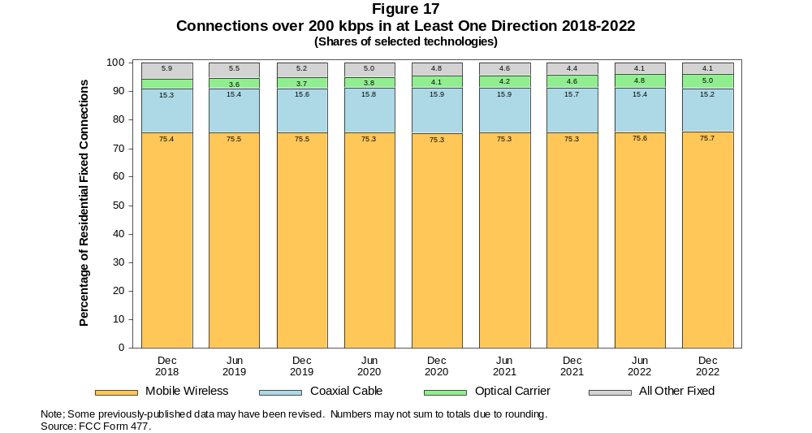

Figure 18
Residential Connections over 200 kbps in at Least One Direction by Technology 2018-2022
(in thousands)

 | 2018 | 2019 |  | 2020 |  | 2021 |  | 2022
Technology | Dec | Jun | Dec | Jun | Dec | Jun | Dec | Jun | Dec
Total | 378,290 | 383,620 | 388,360 | 403,230 | 407,650 | 415,260 | 436,580 | 442,439 | 448,601
Mobile | 276,940 | 280,490 | 283,640 | 294,300 | 296,030 | 301,680 | 320,780 | 325,832 | 330,065
Fixed | 101,350 | 103,130 | 104,720 | 108,920 | 111,620 | 113,580 | 115,790 | 116,608 | 118,536
Copper Wire¹ | 20,206 | 19,041 | 18,237 | 17,718 | 16,983 | 16,344 | 15,269 | 13,978 | 13,101
Coaxial Cable | 63,813 | 65,457 | 67,141 | 70,710 | 72,543 | 73,844 | 74,599 | 74,442 | 74,533
Optical Carrier | 14,205 | 15,410 | 16,011 | 16,986 | 18,384 | 19,414 | 21,531 | 22,941 | 24,456
Satellite | 1,787 | 1,805 | 1,795 | 1,815 | 1,752 | 1,728 | 1,692 | 1,841 | 1,949
Fixed Wireless | 1,338 | 1,421 | 1,535 | 1,694 | 1,959 | 2,251 | 2,701 | 3,406 | 4,498
Licensed | - | - | - | - | - | - | - | 1,841 | 3,022
Unlicensed | - | - | - | - | - | - | - | 1,565 | 1,476
¹ Power Line and Other are summarized with Copper Wire for confidentiality reasons. See Technical Notes at the end of the report for a description of FCC
Form 477 technology categories and other reporting requirements.
* = Data withheld for confidentiality reasons. # = Rounds to zero. - = Data was not collected.
Note: Some previously-published data may have been revised. Numbers may not sum to totals due to rounding.
Source: FCC Form 477.

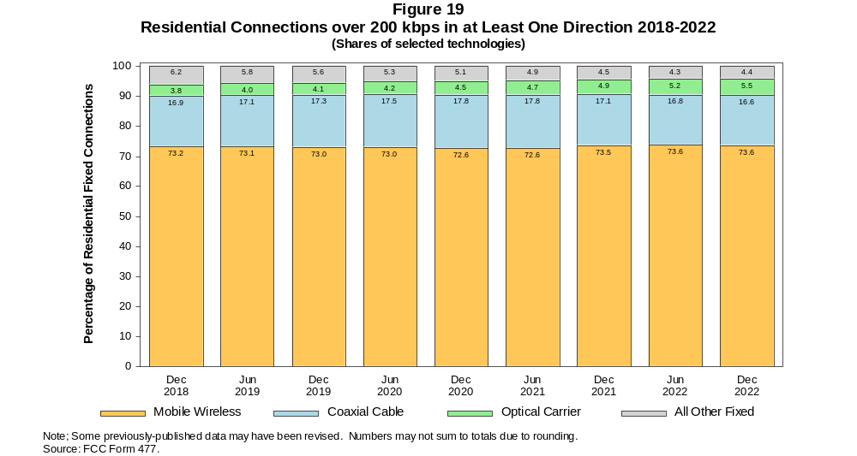

Figure 20
Fixed Connections at Least 10 Mbps Downstream and 1 Mbps Upstream by Technology 2018-2022
(in thousands)

 | 2018 | 2019 |  | 2020 |  | 2021 |  | 2022
Technology | Dec | Jun | Dec | Jun | Dec | Jun | Dec | Jun | Dec
Total | 97,302 | 100,480 | 103,610 | 109,180 | 112,450 | 115,770 | 118,770 | 120,370 | 122,664
Copper Wire¹ | 12,335 | 12,094 | 12,011 | 12,735 | 12,086 | 12,347 | 11,681 | 10,683 | 10,318
Coaxial Cable | 67,716 | 69,704 | 71,934 | 75,391 | 77,513 | 79,035 | 79,956 | 79,676 | 79,819
Optical Carrier | 14,815 | 16,078 | 16,854 | 18,008 | 19,555 | 20,813 | 23,058 | 24,820 | 26,198
Satellite | 1,677 | 1,726 | 1,737 | 1,778 | 1,727 | 1,717 | 1,700 | 1,863 | 1,935
Fixed Wireless | 759 | 879 | 1,078 | 1,263 | 1,564 | 1,860 | 2,379 | 3,328 | 4,396
Licensed | - | - | - | - | - | - | - | 1,907 | 3,052
Unlicensed | - | - | - | - | - | - | - | 1,421 | 1,344
¹ Power Line and Other are summarized with Copper Wire for confidentiality reasons. See Technical Notes at the end of the report for a description of FCC
Form 477 technology categories and other reporting requirements.
* = Data withheld for confidentiality reasons. # = Rounds to zero. - = Data was not collected.
Note: Some previously-published data may have been revised. Numbers may not sum to totals due to rounding.
Source: FCC Form 477.

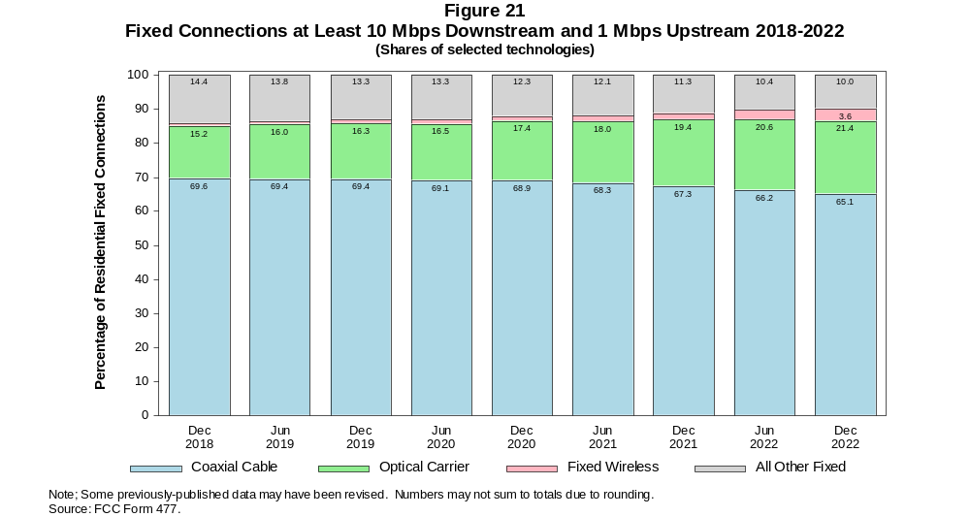

Figure 22
Residential Fixed Connections at Least 10 Mbps Downstream and 1 Mbps Upstream by Technology 2018-2022
(in thousands)

 | 2018 | 2019 |  | 2020 |  | 2021 |  | 2022
Technology | Dec | Jun | Dec | Jun | Dec | Jun | Dec | Jun | Dec
Total | 89,873 | 92,714 | 95,665 | 101,220 | 104,200 | 107,210 | 109,980 | 111,497 | 113,886
Copper Wire¹ | 11,143 | 10,871 | 10,754 | 11,440 | 10,818 | 11,066 | 10,441 | 9,652 | 9,273
Coaxial Cable | 62,810 | 64,556 | 66,691 | 70,299 | 72,215 | 73,611 | 74,386 | 74,147 | 74,295
Optical Carrier | 13,589 | 14,800 | 15,536 | 16,581 | 18,042 | 19,145 | 21,286 | 22,803 | 24,344
Satellite | 1,655 | 1,702 | 1,708 | 1,745 | 1,691 | 1,676 | 1,656 | 1,806 | 1,884
Fixed Wireless | 676 | 784 | 975 | 1,151 | 1,434 | 1,714 | 2,206 | 3,090 | 4,091
Licensed | - | - | - | - | - | - | - | 1,798 | 2,871
Unlicensed | - | - | - | - | - | - | - | 1,291 | 1,220
¹ Power Line and Other are summarized with Copper Wire for confidentiality reasons. See Technical Notes at the end of the report for a description of FCC
Form 477 technology categories and other reporting requirements.
* = Data withheld for confidentiality reasons. # = Rounds to zero. - = Data was not collected.
Note: Some previously-published data may have been revised. Numbers may not sum to totals due to rounding.
Source: FCC Form 477.

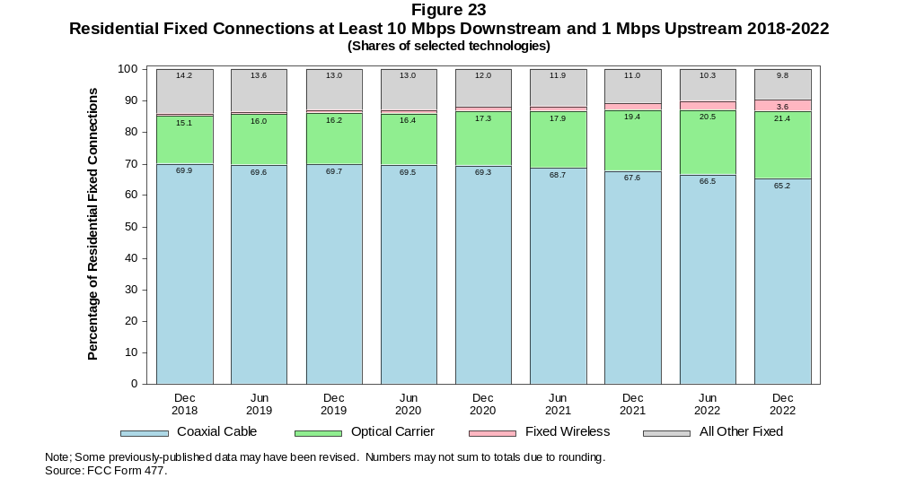

Figure 24
Fixed Connections at Least 25 Mbps Downstream and 3 Mbps Upstream by Technology 2018-2022
(in thousands)

 | 2018 | 2019 |  | 2020 |  | 2021 |  | 2022
Technology | Dec | Jun | Dec | Jun | Dec | Jun | Dec | Jun | Dec
Total | 82,965 | 86,763 | 90,490 | 97,000 | 101,630 | 106,790 | 110,630 | 113,048 | 116,189
Copper Wire¹ | * | * | * | * | * | 6,688 | 6,538 | 6,010 | 6,089
Coaxial Cable | 62,880 | 64,938 | 67,171 | 71,856 | 74,169 | 77,502 | 78,656 | 78,599 | 78,985
Optical Carrier | 13,605 | 14,902 | 15,866 | 17,091 | 18,840 | 20,171 | 22,459 | 24,282 | 25,761
Satellite | * | * | * | * | * | 1,328 | 1,353 | 1,552 | 1,685
Fixed Wireless | 267 | 343 | 468 | 571 | 805 | 1,105 | 1,620 | 2,605 | 3,669
Licensed | - | - | - | - | - | - | - | 1,797 | 2,801
Unlicensed | - | - | - | - | - | - | - | 808 | 868
¹ Power Line and Other are summarized with Copper Wire for confidentiality reasons. See Technical Notes at the end of the report for a description of FCC
Form 477 technology categories and other reporting requirements.
* = Data withheld for confidentiality reasons. # = Rounds to zero. - = Data was not collected.
Note: Some previously-published data may have been revised. Numbers may not sum to totals due to rounding.
Source: FCC Form 477.

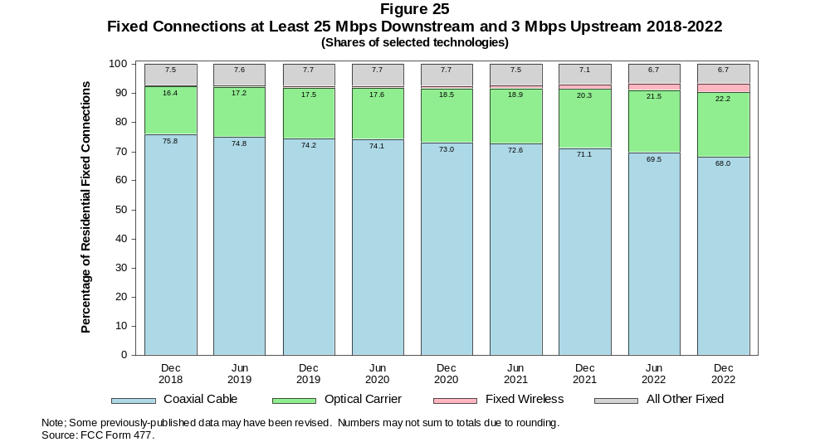

Figure 26
Residential Fixed Connections at Least 25 Mbps Downstream and 3 Mbps Upstream by Technology 2018-2022
(in thousands)

 | 2018 | 2019 |  | 2020 |  | 2021 |  | 2022
Technology | Dec | Jun | Dec | Jun | Dec | Jun | Dec | Jun | Dec
Total | 76,873 | 80,272 | 83,740 | 90,185 | 94,451 | 99,254 | 102,800 | 104,994 | 108,154
Copper Wire¹ | * | * | * | * | * | 6,068 | 5,930 | 5,511 | 5,541
Coaxial Cable | 58,342 | 60,125 | 62,231 | 67,017 | 69,098 | 72,268 | 73,262 | 73,214 | 73,556
Optical Carrier | 12,546 | 13,780 | 14,690 | 15,796 | 17,445 | 18,615 | 20,795 | 22,354 | 23,999
Satellite | * | * | * | * | * | 1,288 | 1,311 | 1,497 | 1,637
Fixed Wireless | 234 | 299 | 415 | 512 | 727 | 1,015 | 1,506 | 2,417 | 3,420
Licensed | - | - | - | - | - | - | - | 1,698 | 2,637
Unlicensed | - | - | - | - | - | - | - | 719 | 784
¹ Power Line and Other are summarized with Copper Wire for confidentiality reasons. See Technical Notes at the end of the report for a description of FCC
Form 477 technology categories and other reporting requirements.
* = Data withheld for confidentiality reasons. # = Rounds to zero. - = Data was not collected.
Note: Some previously-published data may have been revised. Numbers may not sum to totals due to rounding.
Source: FCC Form 477.

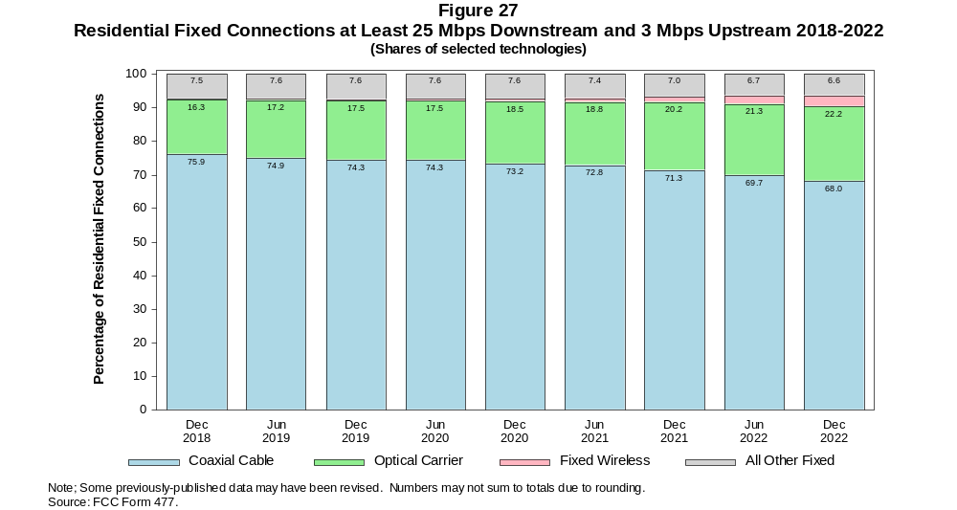

Figure 28
Fixed Connections at Least 100 Mbps Downstream and 20 Mbps Upstream by Technology 2018-2022
(in thousands)

 | 2018 | 2019 |  | 2020 |  | 2021 |  | 2022
Technology | Dec | Jun | Dec | Jun | Dec | Jun | Dec | Jun | Dec
Total | 18,750 | 22,236 | 25,621 | 29,570 | 34,493 | 38,563 | 43,352 | 52,836 | 58,395
Copper Wire¹ | 404 | 566 | * | * | * | * | * | * | *
Coaxial Cable | 9,466 | 11,426 | 13,088 | 15,496 | 18,420 | 20,924 | 23,298 | 29,953 | 33,391
Optical Carrier | 8,815 | 10,146 | 11,634 | 13,086 | 14,933 | 16,373 | 18,705 | 20,982 | 23,000
Satellite | 0 | 0 | * | * | * | * | * | * | *
Fixed Wireless | 65 | 97 | 119 | 116 | 143 | 180 | 239 | 500 | 880
Licensed | - | - | - | - | - | - | - | 302 | 675
Unlicensed | - | - | - | - | - | - | - | 198 | 205
¹ Power Line and Other are summarized with Copper Wire for confidentiality reasons. See Technical Notes at the end of the report for a description of FCC
Form 477 technology categories and other reporting requirements.
* = Data withheld for confidentiality reasons. # = Rounds to zero. - = Data was not collected.
Note: Some previously-published data may have been revised. Numbers may not sum to totals due to rounding.
Source: FCC Form 477.

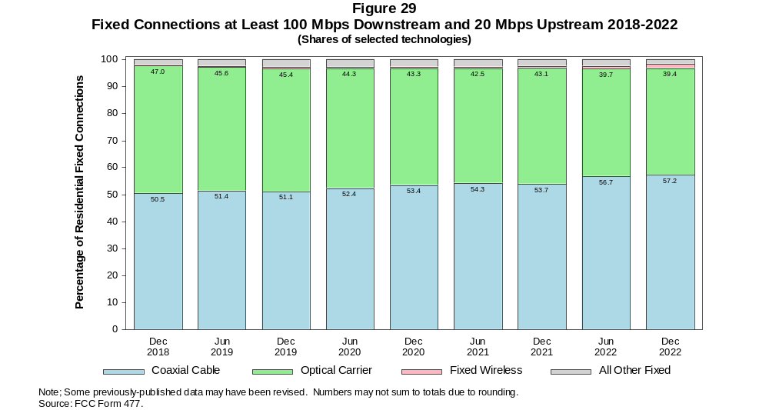

Figure 30
Residential Fixed Connections at Least 100 Mbps Downstream and 20 Mbps Upstream by Technology 2018-2022
(in thousands)

 | 2018 | 2019 |  | 2020 |  | 2021 |  | 2022
Technology | Dec | Jun | Dec | Jun | Dec | Jun | Dec | Jun | Dec
Total | 17,101 | 20,338 | 23,485 | 27,179 | 31,773 | 35,456 | 39,921 | 49,009 | 54,471
Copper Wire¹ | 241 | 371 | * | * | * | * | * | * | *
Coaxial Cable | 8,512 | 10,312 | 11,883 | 14,157 | 16,843 | 19,128 | 21,298 | 27,827 | 31,087
Optical Carrier | 8,292 | 9,574 | 10,952 | 12,303 | 14,055 | 15,329 | 17,537 | 19,508 | 21,672
Satellite | 0 | 0 | * | * | * | * | * | * | *
Fixed Wireless | 56 | 80 | 102 | 98 | 118 | 158 | 215 | 450 | 801
Licensed | - | - | - | - | - | - | - | 277 | 616
Unlicensed | - | - | - | - | - | - | - | 174 | 185
¹ Power Line and Other are summarized with Copper Wire for confidentiality reasons. See Technical Notes at the end of the report for a description of FCC
Form 477 technology categories and other reporting requirements.
* = Data withheld for confidentiality reasons. # = Rounds to zero. - = Data was not collected.
Note: Some previously-published data may have been revised. Numbers may not sum to totals due to rounding.
Source: FCC Form 477.

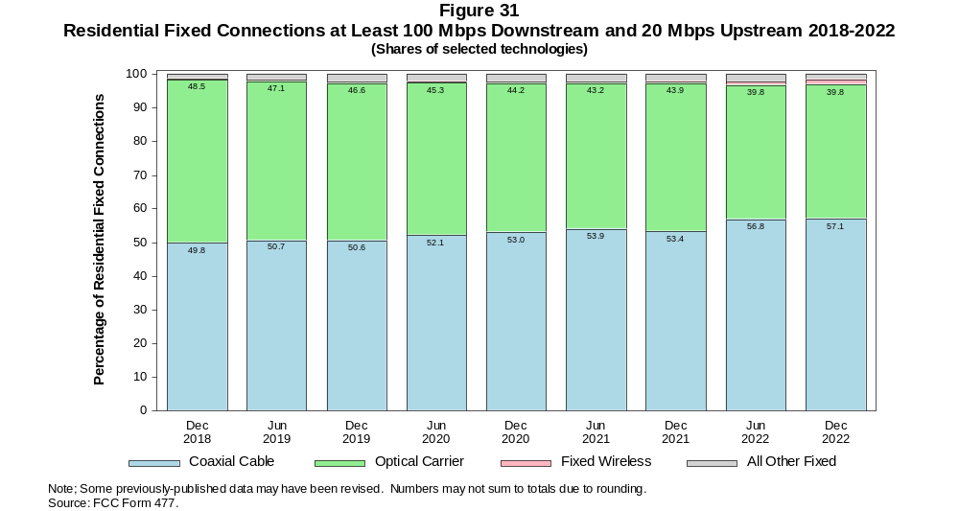

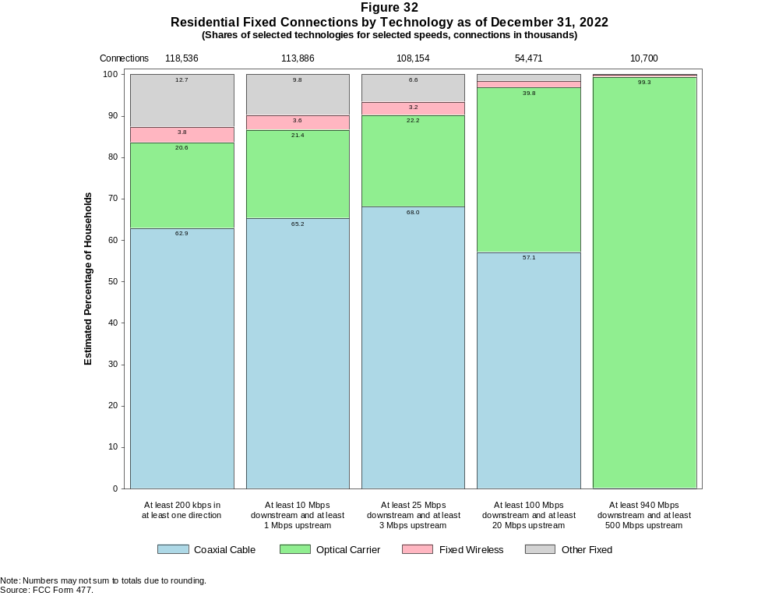

Figure 33
Fixed Connections by Downstream Speed Tier and Technology as of December 31, 2022
(in thousands)

 | Downstream Speed
Technology | Less than  10 Mbps | At least 10 Mbps  and less than  25 Mbps | At least 25 Mbps  and less than  100 Mbps | At least 100 Mbps  and less than  940 Mbps | At least  940 Mbps | Total
Total | 4,702 | 6,587 | 19,759 | 71,298 | 25,692 | 128,038
Copper Wire¹ | 3,737 | 4,410 | 5,221 | 1,235 | 109 | 14,712
Coaxial Cable | 285 | 776 | 8,003 | 56,997 | 14,049 | 80,110
Optical Carrier | 139 | 427 | 2,581 | 11,776 | 11,421 | 26,343
Satellite | * | * | * | * | 0 | 2,039
Fixed Wireless | * | * | * | * | 113 | 4,834

Percentages

Total | 3.7 | 5.1 | 15.4 | 55.7 | 20.1 | 100.0
Copper Wire¹ | 2.9 | 3.4 | 4.1 | 1.0 | 0.1 | 11.5
Coaxial Cable | 0.2 | 0.6 | 6.3 | 44.5 | 11.0 | 62.6
Optical Carrier | 0.1 | 0.3 | 2.0 | 9.2 | 8.9 | 20.6
Satellite | * | * | * | * | 0.0 | 1.6
Fixed Wireless | * | * | * | * | 0.1 | 3.8
¹ Other is summarized with Copper Wire for confidentiality reasons.
* = Data withheld for confidentiality reasons. # = Rounds to Zero.
Note: Numbers may not sum to totals due to rounding.
Source: FCC Form 477.

Figure 34
Residential Fixed Connections by Downstream Speed Tier and Technology as of December 31, 2022
(in thousands)

 | Downstream Speed
Technology | Less than  10 Mbps | At least 10 Mbps  and less than  25 Mbps | At least 25 Mbps  and less than  100 Mbps | At least 100 Mbps  and less than  940 Mbps | At least  940 Mbps | Total
Total | 4,024 | 5,850 | 17,534 | 66,355 | 24,774 | 118,536
Copper Wire¹ | 3,213 | 3,917 | 4,853 | 1,090 | 28 | 13,101
Coaxial Cable | 233 | 683 | 6,778 | 53,164 | 13,674 | 74,533
Optical Carrier | 108 | 336 | 2,160 | 10,890 | 10,963 | 24,456
Satellite | * | * | 1,152 | * | 0 | 1,949
Fixed Wireless | * | * | 2,590 | * | 108 | 4,498

Percentages

Total | 3.4 | 4.9 | 14.8 | 56.0 | 20.9 | 100.0
Copper Wire¹ | 2.7 | 3.3 | 4.1 | 0.9 | 0.0 | 11.1
Coaxial Cable | 0.2 | 0.6 | 5.7 | 44.9 | 11.5 | 62.9
Optical Carrier | 0.1 | 0.3 | 1.8 | 9.2 | 9.2 | 20.6
Satellite | * | * | 1.0 | * | 0.0 | 1.6
Fixed Wireless | * | * | 2.2 | * | 0.1 | 3.8
¹ Other is summarized with Copper Wire for confidentiality reasons.
* = Data withheld for confidentiality reasons. # = Rounds to Zero.
Note: Numbers may not sum to totals due to rounding.
Source: FCC Form 477.

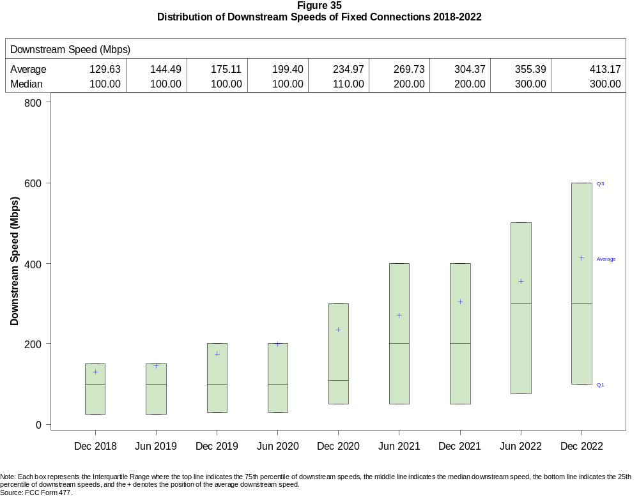

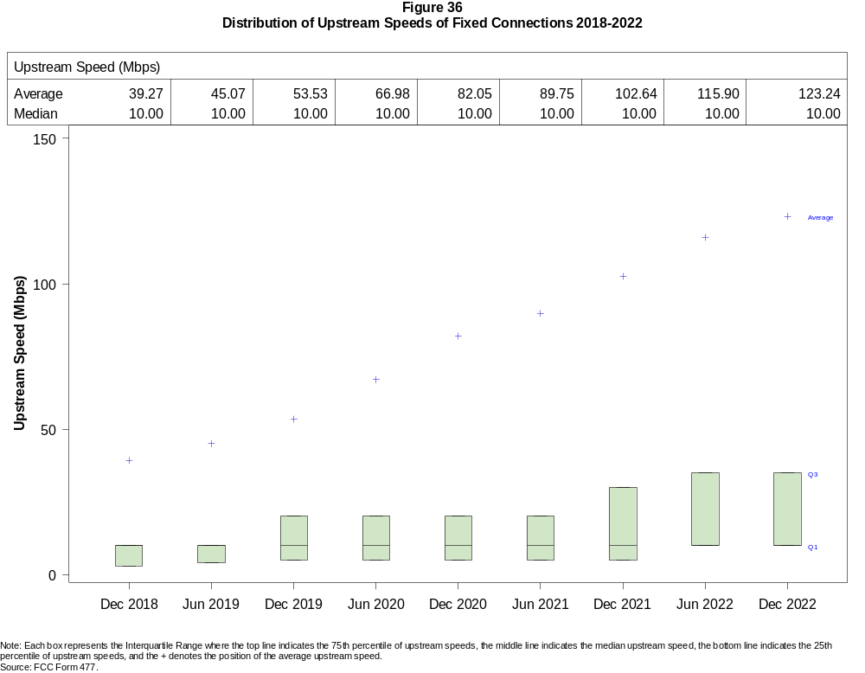

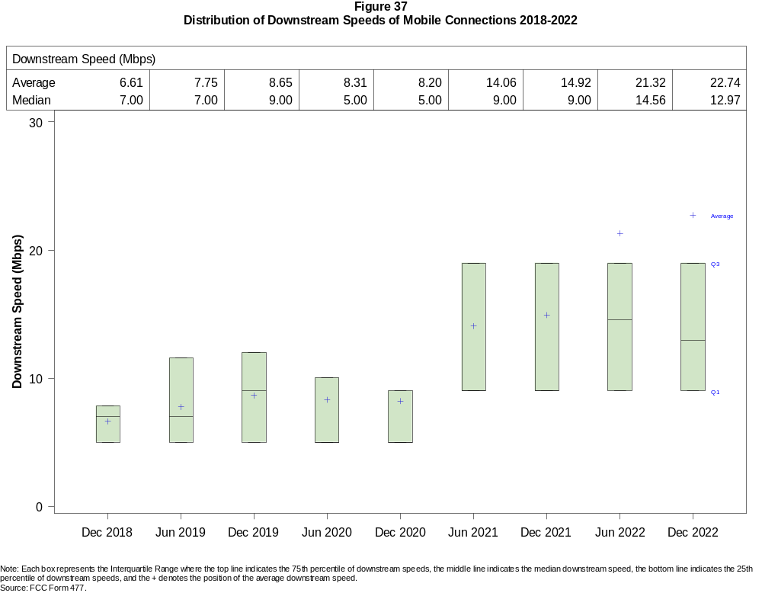

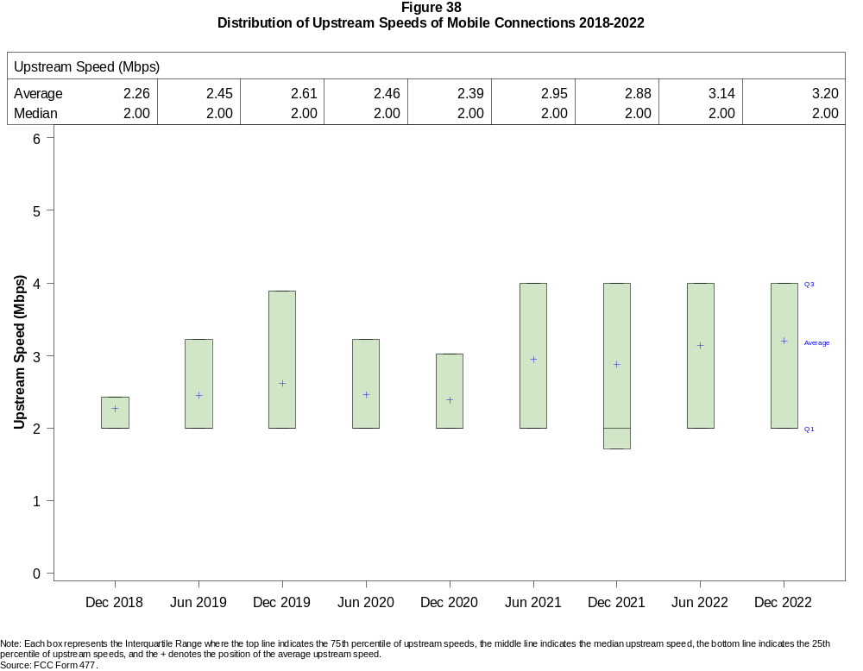

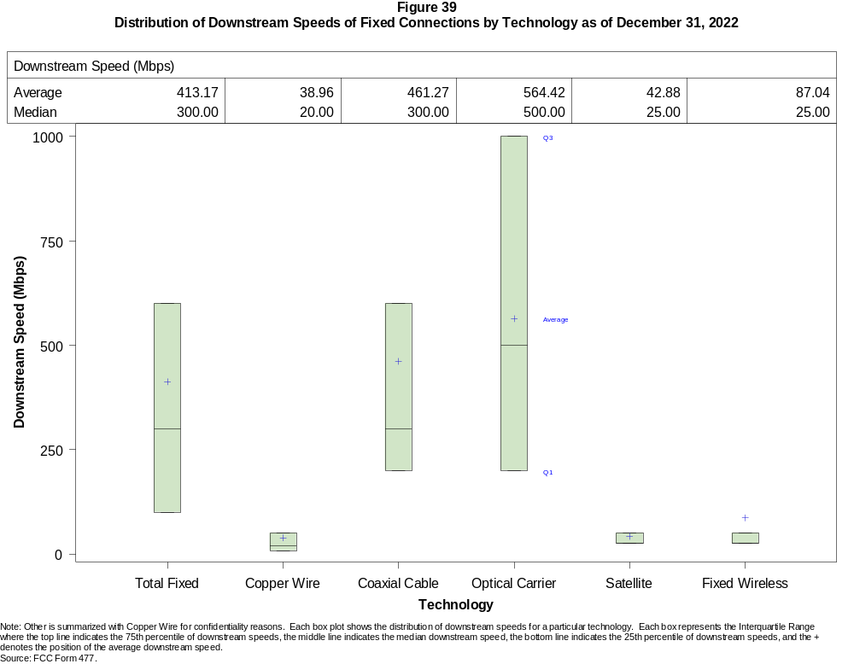

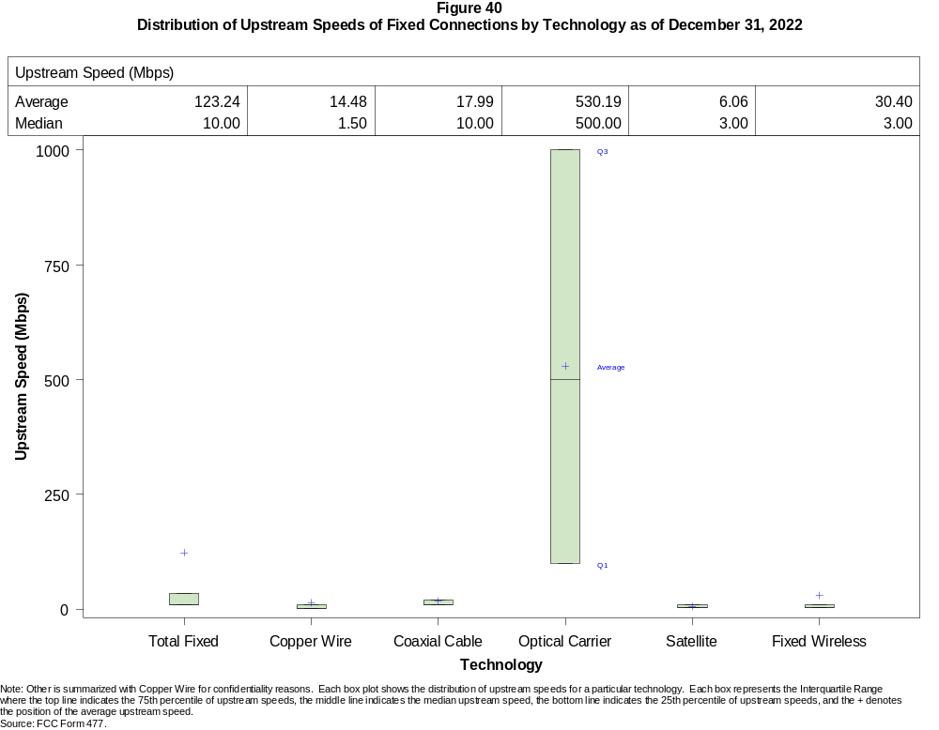

Figure 41
Nationwide Number of Providers of Connections over 200 kbps in at Least One Direction
by Technology 2018-2022

 | 2018 | 2019 |  | 2020 |  | 2021 |  | 2022
Technology | Dec | Jun | Dec | Jun | Dec | Jun | Dec | Jun | Dec
Total | 2,215 | 2,224 | 2,248 | 2,281 | 2,382 | 2,392 | 2,384 | 2,252 | 2,282
Mobile | 71 | 70 | 67 | 64 | 64 | 63 | 62 | 58 | 57
Fixed | 2,195 | 2,203 | 2,230 | 2,266 | 2,371 | 2,378 | 2,371 | 2,243 | 2,273
Copper Wire¹ | 852 | 827 | 803 | 797 | 773 | 755 | 743 | 594 | 570
Coaxial Cable | 381 | 381 | 373 | 365 | 368 | 362 | 352 | 311 | 305
Optical Carrier | 1,269 | 1,310 | 1,331 | 1,380 | 1,442 | 1,477 | 1,505 | 1,475 | 1,519
Satellite | 5 | 5 | 5 | 5 | 6 | 6 | 5 | 4 | 4
Fixed Wireless | 1,239 | 1,249 | 1,281 | 1,313 | 1,397 | 1,383 | 1,359 | 1,237 | 1,247
Licensed | - | - | - | - | - | - | - | 299 | 357
Unlicensed | - | - | - | - | - | - | - | 1,133 | 1,135
¹ Prior to June 2022, Power Line is summarized with Other for confidentiality reasons.
* = 1 - 3 providers. - = Data not collected.
Note: Multiple FCC Form 477 filers within a holding company structure count as one provider. Some previously-published data may have been revised.
Source: FCC Form 477.

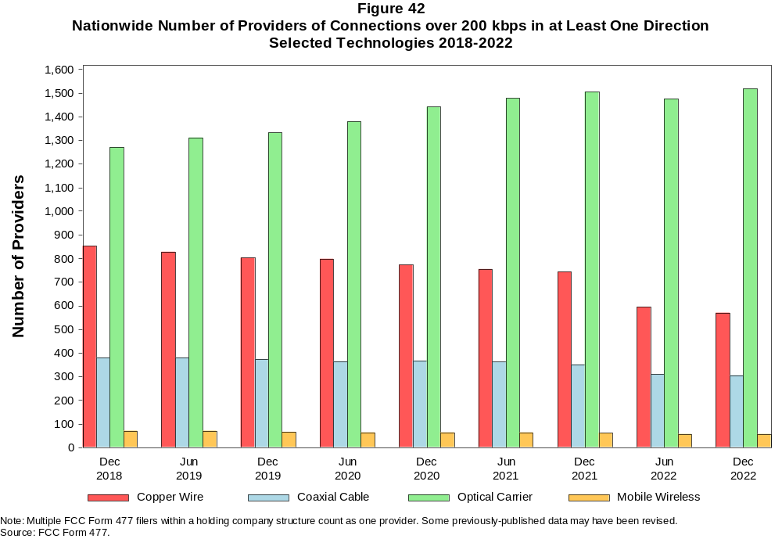

Figure 43
Residential Fixed Connections and Households by State as of December 31, 2022
(Connections and households in thousands)

 |  | At least 200 kbps in  at least One Direction |  | At least 10 Mbps Down  and 1 Mbps Up |  | At least 25 Mbps Down  and 3 Mbps Up |  | At least 100 Mbps Down  and 20 Mbps Up |  | At least 940 Mbps Down  and 500 Mbps Up
State | Households | Connections | Subscribership  Ratio | Connections | Subscribership  Ratio | Connections | Subscribership  Ratio | Connections | Subscribership  Ratio | Connections | Subscribership  Ratio
Alabama | 1,933 | 1,690 | 0.87 | 1,575 | 0.81 | 1,464 | 0.76 | 714 | 0.37 | 167 | 0.09
Alaska | 264 | 242 | 0.92 | 229 | 0.87 | 187 | 0.71 | * | * | 1 | 0.00
American Samoa | 10 | * | * | * | * | * | * | 0 | 0.00 | 0 | 0.00
Arizona | 2,739 | 2,609 | 0.95 | 2,498 | 0.91 | 2,348 | 0.86 | 746 | 0.27 | 89 | 0.03
Arkansas | 1,172 | 992 | 0.85 | 896 | 0.76 | 801 | 0.68 | 402 | 0.34 | 76 | 0.06
California | 13,316 | 12,855 | 0.97 | 12,503 | 0.94 | 11,922 | 0.90 | 5,132 | 0.39 | 760 | 0.06
Colorado | 2,278 | 2,255 | 0.99 | 2,181 | 0.96 | 2,061 | 0.90 | 798 | 0.35 | 130 | 0.06
Connecticut | 1,410 | 1,300 | 0.92 | 1,274 | 0.90 | 1,210 | 0.86 | 721 | 0.51 | 62 | 0.04
Delaware | 389 | 334 | 0.86 | 332 | 0.85 | 331 | 0.85 | 207 | 0.53 | * | *
District of Columbia | 316 | 277 | 0.88 | 273 | 0.87 | 272 | 0.86 | 180 | 0.57 | * | *
Florida | 8,353 | 8,778 | 1.05 | 8,546 | 1.02 | 8,280 | 0.99 | 4,093 | 0.49 | 613 | 0.07
Georgia | 3,946 | 3,725 | 0.94 | 3,561 | 0.90 | 3,370 | 0.85 | 1,890 | 0.48 | 462 | 0.12
Guam | 42 | 37 | 0.87 | 34 | 0.82 | * | * | * | * | 0 | 0.00
Hawaii | 484 | 501 | 1.04 | 492 | 1.02 | 476 | 0.98 | * | * | * | *
Idaho | 675 | 620 | 0.92 | 573 | 0.85 | 487 | 0.72 | 295 | 0.44 | 28 | 0.04
Illinois | 4,969 | 4,353 | 0.88 | 4,199 | 0.84 | 3,950 | 0.80 | 1,943 | 0.39 | 188 | 0.04
Indiana | 2,654 | 2,343 | 0.88 | 2,213 | 0.83 | 2,062 | 0.78 | 1,047 | 0.39 | 199 | 0.07
Iowa | 1,290 | 1,100 | 0.85 | 1,028 | 0.80 | 924 | 0.72 | 638 | 0.49 | 59 | 0.05
Kansas | 1,149 | 1,017 | 0.89 | 969 | 0.84 | 899 | 0.78 | 452 | 0.39 | 151 | 0.13
Kentucky | 1,769 | 1,569 | 0.89 | 1,471 | 0.83 | 1,355 | 0.77 | 681 | 0.38 | 125 | 0.07
Louisiana | 1,765 | 1,493 | 0.85 | 1,393 | 0.79 | 1,286 | 0.73 | 538 | 0.30 | 113 | 0.06
Maine | 580 | 590 | 1.02 | 554 | 0.95 | 491 | 0.85 | 115 | 0.20 | 2 | 0.00
Maryland | 2,318 | 2,219 | 0.96 | 2,185 | 0.94 | 2,164 | 0.93 | 1,467 | 0.63 | * | *
Massachusetts | 2,741 | 2,667 | 0.97 | 2,625 | 0.96 | 2,612 | 0.95 | 1,516 | 0.55 | 331 | 0.12
Michigan | 4,009 | 3,604 | 0.90 | 3,453 | 0.86 | 3,274 | 0.82 | 1,267 | 0.32 | 91 | 0.02
Minnesota | 2,256 | 2,064 | 0.91 | 1,972 | 0.87 | 1,831 | 0.81 | 737 | 0.33 | 67 | 0.03
Mississippi | 1,121 | 913 | 0.81 | 831 | 0.74 | 720 | 0.64 | 468 | 0.42 | 152 | 0.14
Missouri | 2,458 | 2,163 | 0.88 | 1,999 | 0.81 | 1,816 | 0.74 | 977 | 0.40 | 236 | 0.10
Montana | 444 | 418 | 0.94 | 388 | 0.87 | 343 | 0.77 | 81 | 0.18 | 9 | 0.02
Nebraska | 776 | 697 | 0.90 | 669 | 0.86 | 626 | 0.81 | 275 | 0.35 | 41 | 0.05

Figure 43 - Continued
Residential Fixed Connections and Households by State as of December 31, 2022
(Connections and households in thousands)

 |  | At least 200 kbps in  at least One Direction |  | At least 10 Mbps Down  and 1 Mbps Up |  | At least 25 Mbps Down  and 3 Mbps Up |  | At least 100 Mbps Down  and 20 Mbps Up |  | At least 940 Mbps Down  and 500 Mbps Up
State | Households | Connections | Subscribership  Ratio | Connections | Subscribership  Ratio | Connections | Subscribership  Ratio | Connections | Subscribership  Ratio | Connections | Subscribership  Ratio
Nevada | 1,164 | 1,120 | 0.96 | 1,086 | 0.93 | 1,040 | 0.89 | 339 | 0.29 | 47 | 0.04
New Hampshire | 545 | 539 | 0.99 | 524 | 0.96 | 504 | 0.92 | 288 | 0.53 | 5 | 0.01
New Jersey | 3,438 | 3,220 | 0.94 | 3,178 | 0.92 | 3,157 | 0.92 | 2,353 | 0.68 | * | *
New Mexico | 813 | 710 | 0.87 | 655 | 0.81 | 583 | 0.72 | 172 | 0.21 | 21 | 0.03
New York | 7,605 | 6,966 | 0.92 | 6,892 | 0.91 | 6,708 | 0.88 | 4,092 | 0.54 | 1,004 | 0.13
North Carolina | 4,105 | 4,141 | 1.01 | 3,884 | 0.95 | 3,712 | 0.90 | 1,761 | 0.43 | 376 | 0.09
North Dakota | 320 | 290 | 0.91 | 285 | 0.89 | 279 | 0.87 | 255 | 0.80 | 10 | 0.03
Northern Mariana Isl | 16 | * | * | * | * | * | * | 0 | 0.00 | 0 | 0.00
Ohio | 4,789 | 4,303 | 0.90 | 4,122 | 0.86 | 3,868 | 0.81 | 1,630 | 0.34 | 157 | 0.03
Oklahoma | 1,523 | 1,292 | 0.85 | 1,205 | 0.79 | 1,098 | 0.72 | 527 | 0.35 | 151 | 0.10
Oregon | 1,681 | 1,576 | 0.94 | 1,510 | 0.90 | 1,435 | 0.85 | 524 | 0.31 | 76 | 0.04
Pennsylvania | 5,194 | 4,703 | 0.91 | 4,499 | 0.87 | 4,432 | 0.85 | 2,756 | 0.53 | 564 | 0.11
Puerto Rico | 1,220 | 750 | 0.61 | 680 | 0.56 | 566 | 0.46 | 168 | 0.14 | 9 | 0.01
Rhode Island | 432 | 410 | 0.95 | 405 | 0.94 | 404 | 0.93 | 213 | 0.49 | * | *
South Carolina | 2,023 | 1,990 | 0.98 | 1,916 | 0.95 | 1,809 | 0.89 | 937 | 0.46 | 124 | 0.06
South Dakota | 351 | 321 | 0.91 | 316 | 0.90 | 307 | 0.87 | 231 | 0.66 | 8 | 0.02
Tennessee | 2,714 | 2,496 | 0.92 | 2,403 | 0.89 | 2,299 | 0.85 | 1,278 | 0.47 | 375 | 0.14
Texas | 10,491 | 9,932 | 0.95 | 9,608 | 0.92 | 9,084 | 0.87 | 5,119 | 0.49 | 1,325 | 0.13
Utah | 1,063 | 1,054 | 0.99 | 1,025 | 0.96 | 975 | 0.92 | 471 | 0.44 | 149 | 0.14
Vermont | 266 | 322 | 1.21 | 270 | 1.02 | 237 | 0.89 | 113 | 0.42 | 15 | 0.06
Virgin Islands | 43 | * | * | * | * | * | * | * | * | 0 | 0.00
Virginia | 3,290 | 2,999 | 0.91 | 2,874 | 0.87 | 2,821 | 0.86 | 1,606 | 0.49 | 606 | 0.18
Washington | 2,979 | 2,923 | 0.98 | 2,795 | 0.94 | 2,675 | 0.90 | 974 | 0.33 | 118 | 0.04
West Virginia | 716 | 565 | 0.79 | 501 | 0.70 | 443 | 0.62 | 247 | 0.35 | 15 | 0.02
Wisconsin | 2,425 | 2,220 | 0.92 | 2,083 | 0.86 | 1,894 | 0.78 | 620 | 0.26 | 64 | 0.03
Wyoming | 234 | 222 | 0.95 | 209 | 0.89 | 194 | 0.83 | 49 | 0.21 | 4 | 0.02
Total | 127,067 | 118,536 | 0.93 | 113,886 | 0.90 | 108,154 | 0.85 | 54,471 | 0.43 | 10,700 | 0.08
# = Rounds to Zero; * = Data withheld for confidentiality reasons.
Note: Numbers may not sum to totals due to rounding.
Sources: FCC Form 477 (Connections); 2018-2022 ACS 5-year estimates; Census 2010.

Figure 44
Connections by Type of End User by State as of December 31, 2022
(Connections in thousands)

 | Connections |  | Percentages
State | Residential | Business | Residential | Business | Total
Alabama | 6,569 | 1,051 | 86.2 | 13.8 | 7,620
Alaska | 924 | 152 | 85.9 | 14.1 | 1,076
American Samoa | * | * | * | * | *
Arizona | 9,656 | 1,452 | 86.9 | 13.1 | 11,108
Arkansas | 3,894 | 536 | 87.9 | 12.1 | 4,430
California | 53,778 | 9,776 | 84.6 | 15.4 | 63,554
Colorado | 7,628 | 1,521 | 83.4 | 16.6 | 9,149
Connecticut | 4,947 | 900 | 84.6 | 15.4 | 5,847
Delaware | 1,326 | 283 | 82.4 | 17.6 | 1,609
District of Columbia | 1,171 | 709 | 62.3 | 37.7 | 1,881
Florida | 31,759 | 5,018 | 86.4 | 13.6 | 36,777
Georgia | 14,725 | 2,593 | 85.0 | 15.0 | 17,318
Guam | 140 | 60 | 70.0 | 30.0 | 199
Hawaii | 1,926 | 358 | 84.3 | 15.7 | 2,284
Idaho | 2,304 | 349 | 86.8 | 13.2 | 2,653
Illinois | 16,950 | 3,324 | 83.6 | 16.4 | 20,274
Indiana | 8,539 | 1,322 | 86.6 | 13.4 | 9,861
Iowa | 3,982 | 640 | 86.2 | 13.8 | 4,622
Kansas | 3,751 | 563 | 87.0 | 13.0 | 4,314
Kentucky | 5,706 | 913 | 86.2 | 13.8 | 6,619
Louisiana | 6,277 | 900 | 87.5 | 12.5 | 7,177
Maine | 1,758 | 340 | 83.8 | 16.2 | 2,098
Maryland | 8,477 | 1,414 | 85.7 | 14.3 | 9,890
Massachusetts | 9,422 | 1,827 | 83.8 | 16.2 | 11,249
Michigan | 12,949 | 2,395 | 84.4 | 15.6 | 15,344
Minnesota | 7,288 | 1,300 | 84.9 | 15.1 | 8,587
Mississippi | 3,910 | 468 | 89.3 | 10.7 | 4,378
Missouri | 7,903 | 1,376 | 85.2 | 14.8 | 9,279
Montana | 1,375 | 252 | 84.5 | 15.5 | 1,628
Nebraska | 2,457 | 501 | 83.1 | 16.9 | 2,958
Nevada | 4,345 | 596 | 87.9 | 12.1 | 4,941
New Hampshire | 1,767 | 374 | 82.5 | 17.5 | 2,142
New Jersey | 12,851 | 2,338 | 84.6 | 15.4 | 15,189
New Mexico | 2,770 | 414 | 87.0 | 13.0 | 3,184
New York | 27,930 | 5,407 | 83.8 | 16.2 | 33,337
North Carolina | 13,953 | 2,511 | 84.7 | 15.3 | 16,464
North Dakota | 1,006 | 170 | 85.6 | 14.4 | 1,175
Northern Mariana Isl | * | * | * | * | *
Ohio | 15,292 | 2,846 | 84.3 | 15.7 | 18,138
Oklahoma | 5,114 | 789 | 86.6 | 13.4 | 5,903
Oregon | 5,449 | 1,053 | 83.8 | 16.2 | 6,502
Pennsylvania | 17,153 | 3,076 | 84.8 | 15.2 | 20,229
Puerto Rico | 3,156 | 274 | 92.0 | 8.0 | 3,430
Rhode Island | 1,481 | 280 | 84.1 | 15.9 | 1,762
South Carolina | 6,783 | 1,080 | 86.3 | 13.7 | 7,863
South Dakota | 1,129 | 173 | 86.7 | 13.3 | 1,302
Tennessee | 9,240 | 1,511 | 85.9 | 14.1 | 10,751
Texas | 41,004 | 6,589 | 86.2 | 13.8 | 47,593
Utah | 3,914 | 824 | 82.6 | 17.4 | 4,738
Vermont | 837 | 219 | 79.2 | 20.8 | 1,056
Virgin Islands | 46 | 10 | 82.1 | 17.9 | 56
Virginia | 11,435 | 2,073 | 84.7 | 15.3 | 13,508
Washington | 10,168 | 1,946 | 83.9 | 16.1 | 12,113
West Virginia | 2,141 | 277 | 88.6 | 11.4 | 2,418
Wisconsin | 7,276 | 1,402 | 83.8 | 16.2 | 8,678
Wyoming | 770 | 134 | 85.1 | 14.9 | 905
Total | 448,601 | 78,696 | 85.1 | 14.9 | 527,297
* = Data withheld for confidentiality reasons. # = Rounds to Zero.
Note: Numbers may not sum to totals due to rounding.
Source: FCC Form 477.

Figure 45
Connections by Technology by State as of December 31, 2022
(Connections in thousands)

State | Copper  Wire¹ | Coaxial  Cable | Optical  Carrier | Other  Fixed² | Mobile  Wireless | Total
Alabama | 316 | 997 | 394 | 119 | 5,794 | 7,620
Alaska | 67 | * | 16 | * | 797 | 1,076
American Samoa | 0 | * | * | * | * | *
Arizona | 447 | 1,842 | 227 | 253 | 8,340 | 11,108
Arkansas | 261 | 476 | 253 | 83 | 3,358 | 4,430
California | 1,870 | 9,568 | 1,888 | 678 | 49,551 | 63,554
Colorado | * | 1,631 | 280 | * | 6,741 | 9,149
Connecticut | * | 1,125 | 145 | * | 4,446 | 5,847
Delaware | * | * | * | 12 | * | 1,609
District of Columbia | * | * | * | 13 | 1,576 | 1,881
Florida | 908 | 6,508 | 1,743 | 286 | 27,333 | 36,777
Georgia | 659 | 2,300 | 923 | 154 | 13,282 | 17,318
Guam | * | * | 1 | * | * | 199
Hawaii | * | * | * | 9 | 1,732 | 2,284
Idaho | 160 | 295 | 102 | 112 | 1,985 | 2,653
Illinois | 704 | 3,175 | 473 | 329 | 15,593 | 20,274
Indiana | 382 | 1,399 | 562 | 171 | 7,347 | 9,861
Iowa | 216 | 474 | 384 | 115 | 3,432 | 4,622
Kansas | 139 | 518 | 345 | 98 | 3,215 | 4,314
Kentucky | 285 | 894 | 433 | 83 | 4,924 | 6,619
Louisiana | 283 | 923 | 303 | 109 | 5,560 | 7,177
Maine | 87 | 497 | 42 | 32 | 1,441 | 2,098
Maryland | * | 1,340 | * | 64 | 7,520 | 9,890
Massachusetts | * | 2,139 | 643 | * | 8,367 | 11,249
Michigan | 532 | 2,818 | 287 | 228 | 11,478 | 15,344
Minnesota | 354 | 1,356 | 360 | 148 | 6,369 | 8,587
Mississippi | 260 | 382 | 284 | 75 | 3,377 | 4,378
Missouri | 436 | 1,132 | 574 | 201 | 6,937 | 9,279
Montana | 76 | 261 | 60 | 67 | 1,165 | 1,628
Nebraska | 103 | 391 | 202 | 61 | 2,201 | 2,958

Figure 45 - Continued
Connections by Technology by State as of December 31, 2022
(Connections in thousands)

State | Copper  Wire¹ | Coaxial  Cable | Optical  Carrier | Other  Fixed² | Mobile  Wireless | Total
Nevada | 124 | 859 | 128 | 95 | 3,735 | 4,941
New Hampshire | 40 | * | 60 | * | 1,530 | 2,142
New Jersey | 58 | 2,084 | 1,275 | 58 | 11,715 | 15,189
New Mexico | 185 | 445 | 63 | 68 | 2,422 | 3,184
New York | 130 | 4,937 | 2,344 | 150 | 25,776 | 33,337
North Carolina | 503 | 2,866 | 888 | 184 | 12,023 | 16,464
North Dakota | 15 | 173 | 133 | 8 | 847 | 1,175
Northern Mariana Isl | * | * | * | 0 | * | *
Ohio | 602 | 3,167 | 616 | 229 | 13,525 | 18,138
Oklahoma | 254 | 655 | 337 | 154 | 4,503 | 5,903
Oregon | 161 | 1,154 | 271 | 117 | 4,800 | 6,502
Pennsylvania | 302 | 3,418 | 1,175 | 156 | 15,179 | 20,229
Puerto Rico | * | * | 149 | 83 | * | 3,430
Rhode Island | * | * | * | 8 | 1,322 | 1,762
South Carolina | 265 | 1,297 | 491 | 92 | 5,718 | 7,863
South Dakota | 27 | 202 | 106 | 17 | 950 | 1,302
Tennessee | 293 | 1,451 | 833 | 125 | 8,050 | 10,751
Texas | 1,223 | 5,739 | 2,968 | 786 | 36,878 | 47,593
Utah | 114 | 631 | 278 | 105 | 3,609 | 4,738
Vermont | 108 | 193 | 74 | 15 | 666 | 1,056
Virgin Islands | 0 | * | 0 | * | * | 56
Virginia | 167 | 1,751 | 1,143 | 157 | 10,290 | 13,508
Washington | 328 | 2,310 | 289 | 199 | 8,987 | 12,113
West Virginia | * | 420 | 38 | * | 1,810 | 2,418
Wisconsin | 419 | * | 340 | * | 6,285 | 8,678
Wyoming | 35 | 134 | 23 | 55 | 658 | 905
Total | 14,712 | 80,110 | 26,343 | 6,873 | 399,258 | 527,297
* = Data withheld for confidentiality reasons. # = Rounds to Zero.
¹ Other is summarized with Copper Wire for confidentiality reasons.
² Fixed Wireless and Satellite are summarized as Other Fixed for confidentiality reasons.
Note: Numbers may not sum to totals due to rounding.
Source: FCC Form 477.

Figure 46
Percentage of Fixed Connections by Downstream Speed by State as of December 31, 2022

 | Over 200 kbps Upstream and
State | % over 200 kbps  Downstream | % at least 10 Mbps  Downstream | % at least 25 Mbps  Downstream | % at least 100 Mbps  Downstream | % at least 940 Mbps  Downstream
Alabama | 99.8 | 94.2 | 86.9 | 70.2 | 13.8
Alaska | 99.8 | 93.5 | 77.2 | * | *
American Samoa | * | * | * | * | *
Arizona | 99.6 | 96.2 | 90.6 | 74.4 | 16.1
Arkansas | 99.8 | 92.1 | 81.1 | 58.8 | 14.2
California | 99.9 | 97.0 | 92.2 | 78.0 | 19.0
Colorado | 99.8 | 97.3 | 91.5 | 74.3 | 30.9
Connecticut | 100.0 | 97.7 | 93.4 | 84.7 | 24.5
Delaware | 99.9 | 99.4 | 99.0 | 86.6 | 35.9
District of Columbia | 99.9 | 97.5 | 96.6 | 85.5 | 30.0
Florida | 99.8 | 97.8 | 94.4 | 77.7 | 15.8
Georgia | 99.7 | 95.4 | 90.3 | 71.6 | 22.2
Guam | 100.0 | 89.2 | 78.5 | 7.8 | *
Hawaii | 99.9 | 97.3 | 93.9 | * | *
Idaho | 99.6 | 93.7 | 80.1 | 58.9 | 12.7
Illinois | 99.9 | 96.3 | 90.6 | 67.8 | 16.9
Indiana | 99.8 | 95.1 | 88.1 | 66.4 | 16.7
Iowa | 99.9 | 94.6 | 84.9 | 62.8 | 13.8
Kansas | 99.8 | 95.9 | 88.2 | 70.8 | 22.3
Kentucky | 99.8 | 93.8 | 87.2 | 71.9 | 10.6
Louisiana | 99.7 | 93.7 | 85.9 | 69.1 | 14.7
Maine | 99.8 | 92.6 | 83.6 | 71.9 | 5.9
Maryland | 99.9 | 98.1 | 97.0 | 84.2 | 40.3
Massachusetts | 99.9 | 98.1 | 97.5 | 88.2 | 31.4
Michigan | 99.9 | 95.9 | 90.8 | 70.8 | 12.5
Minnesota | 99.9 | 96.4 | 89.4 | 69.5 | 20.7
Mississippi | 99.6 | 91.0 | 78.9 | 59.3 | 27.2
Missouri | 99.7 | 94.4 | 84.7 | 67.2 | 15.9
Montana | 99.7 | 94.5 | 83.2 | 62.5 | 3.8
Nebraska | 99.9 | 96.3 | 90.1 | 74.1 | 11.8

Figure 46 - Continued
Percentage of Fixed Connections by Downstream Speed by State as of December 31, 2022

 | Over 200 kbps Upstream and
State | % over 200 kbps  Downstream | % at least 10 Mbps  Downstream | % at least 25 Mbps  Downstream | % at least 100 Mbps  Downstream | % at least 940 Mbps  Downstream
Nevada | 99.8 | 97.5 | 93.5 | 80.3 | 16.2
New Hampshire | 99.7 | 95.7 | 92.5 | 84.0 | 32.6
New Jersey | 99.9 | 98.6 | 97.8 | 88.6 | 34.0
New Mexico | 99.8 | 93.8 | 83.1 | 58.3 | 16.8
New York | 99.9 | 98.7 | 96.0 | 88.1 | 18.2
North Carolina | 99.7 | 95.3 | 89.7 | 78.6 | 11.9
North Dakota | 99.8 | 98.4 | 95.9 | 87.6 | 51.3
Northern Mariana Isl | * | * | * | * | *
Ohio | 99.9 | 96.1 | 89.8 | 75.6 | 12.4
Oklahoma | 99.6 | 93.3 | 84.6 | 67.1 | 18.8
Oregon | 99.8 | 96.6 | 91.3 | 74.8 | 23.9
Pennsylvania | 99.9 | 96.1 | 94.1 | 80.8 | 31.1
Puerto Rico | 100.0 | 90.2 | 75.6 | 31.9 | 1.4
Rhode Island | 99.7 | 98.5 | 98.1 | 90.6 | 31.6
South Carolina | 99.9 | 96.5 | 90.8 | 77.4 | 11.4
South Dakota | 99.9 | 98.6 | 95.8 | 75.2 | 48.9
Tennessee | 99.8 | 96.3 | 91.8 | 74.7 | 22.1
Texas | 99.8 | 96.8 | 91.3 | 75.1 | 21.5
Utah | 99.9 | 97.5 | 92.6 | 75.4 | 36.1
Vermont | 99.2 | 80.7 | 73.0 | 60.3 | 16.1
Virgin Islands | * | * | * | * | *
Virginia | 99.6 | 96.3 | 93.7 | 81.2 | 30.6
Washington | 99.7 | 96.5 | 91.6 | 77.2 | 29.6
West Virginia | 99.5 | 88.7 | 79.3 | 65.4 | 17.9
Wisconsin | 99.7 | 95.3 | 85.9 | 71.1 | 4.9
Wyoming | 99.7 | 95.0 | 87.3 | 62.5 | 4.1
Total | 99.8 | 96.3 | 91.2 | 75.8 | 20.1
* = Data withheld for confidentiality reasons.
Source: FCC Form 477.

Figure 47
Providers of Connections by Technology by State as of December 31, 2022
(Connections over 200 kbps in at least one direction)

State | Copper  Wire¹ | Coaxial  Cable | Optical  Carrier | Satellite | Fixed  Wireless | Mobile  Wireless | Unduplicated  Total
Alabama | 20 | 14 | 43 | * | 22 | 7 | 75
Alaska | 13 | * | 17 | * | 17 | 11 | 33
American Samoa | 0 | * | * | 0 | * | * | *
Arizona | 20 | 12 | 35 | * | 45 | 7 | 81
Arkansas | 20 | 13 | 52 | * | 31 | 6 | 85
California | 28 | 23 | 67 | * | 126 | 6 | 182
Colorado | 24 | 12 | 74 | * | 67 | 10 | 122
Connecticut | 5 | 5 | 13 | * | 4 | 5 | 23
Delaware | * | * | 13 | * | 4 | * | 23
District of Columbia | 7 | 4 | 18 | * | 7 | 4 | 29
Florida | 19 | 16 | 57 | * | 36 | 6 | 91
Georgia | 25 | 22 | 81 | * | 28 | 6 | 110
Guam | * | * | 4 | 0 | * | * | 4
Hawaii | 5 | * | 9 | * | 4 | 4 | 17
Idaho | 22 | 14 | 37 | * | 42 | 8 | 70
Illinois | 44 | 13 | 88 | * | 72 | 7 | 145
Indiana | 31 | 9 | 81 | * | 61 | 5 | 120
Iowa | 46 | 28 | 183 | * | 81 | 7 | 223
Kansas | 22 | 18 | 63 | * | 43 | 10 | 94
Kentucky | 14 | 23 | 58 | * | 27 | 7 | 94
Louisiana | 14 | 13 | 29 | * | 25 | 7 | 63
Maine | 11 | 4 | 21 | * | 12 | 5 | 37
Maryland | 9 | 12 | 34 | * | 21 | 5 | 60
Massachusetts | 9 | 6 | 28 | * | 14 | 5 | 46
Michigan | 30 | 19 | 74 | * | 48 | 7 | 120
Minnesota | 37 | 17 | 88 | * | 50 | 5 | 123
Mississippi | 16 | 10 | 37 | * | 11 | 6 | 62
Missouri | 32 | 14 | 82 | * | 71 | 7 | 137
Montana | 18 | 5 | 35 | * | 33 | 6 | 60
Nebraska | 22 | 16 | 50 | * | 41 | 7 | 83

Figure 47 - Continued
Providers of Connections by Technology by State as of December 31, 2022
(Connections over 200 kbps in at least one direction)

State | Copper  Wire¹ | Coaxial  Cable | Optical  Carrier | Satellite | Fixed  Wireless | Mobile  Wireless | Unduplicated  Total
Nevada | 15 | 7 | 28 | * | 27 | 6 | 58
New Hampshire | 8 | * | 18 | * | 8 | 5 | 30
New Jersey | 13 | 6 | 27 | * | 7 | 4 | 39
New Mexico | 19 | 6 | 30 | * | 41 | 9 | 68
New York | 33 | 11 | 53 | * | 23 | 5 | 82
North Carolina | 20 | 19 | 53 | * | 24 | 7 | 79
North Dakota | 16 | 5 | 31 | * | 9 | 6 | 44
Northern Mariana Isl | * | * | * | 0 | 0 | * | *
Ohio | 30 | 23 | 80 | * | 58 | 5 | 134
Oklahoma | 35 | 6 | 66 | * | 50 | 10 | 110
Oregon | 31 | 11 | 57 | * | 45 | 6 | 94
Pennsylvania | 23 | 22 | 61 | * | 35 | 8 | 107
Puerto Rico | 5 | * | 23 | * | 39 | * | 50
Rhode Island | * | 4 | 8 | * | * | 4 | 16
South Carolina | 16 | 12 | 35 | * | 11 | 5 | 52
South Dakota | 14 | 7 | 41 | * | 24 | 8 | 67
Tennessee | 16 | 15 | 66 | * | 27 | 6 | 94
Texas | 61 | 23 | 137 | 4 | 148 | 9 | 238
Utah | 15 | 8 | 32 | * | 37 | 9 | 58
Vermont | 8 | 4 | 18 | * | 11 | 5 | 34
Virgin Islands | 0 | * | 0 | * | * | * | 5
Virginia | 21 | 14 | 65 | * | 31 | 7 | 95
Washington | 26 | 21 | 68 | * | 50 | 7 | 102
West Virginia | 7 | 13 | 23 | * | 22 | 6 | 57
Wisconsin | 33 | 15 | 77 | * | 43 | 6 | 109
Wyoming | 12 | 5 | 22 | * | 20 | 9 | 41
Total | 570 | 305 | 1,519 | 4 | 1,247 | 57 | 2,282
* = 1 to 3 providers.
¹ Other is summarized with Copper Wire for confidentiality reasons.
Note: Numbers may not sum to totals due to rounding.
Source: FCC Form 477.

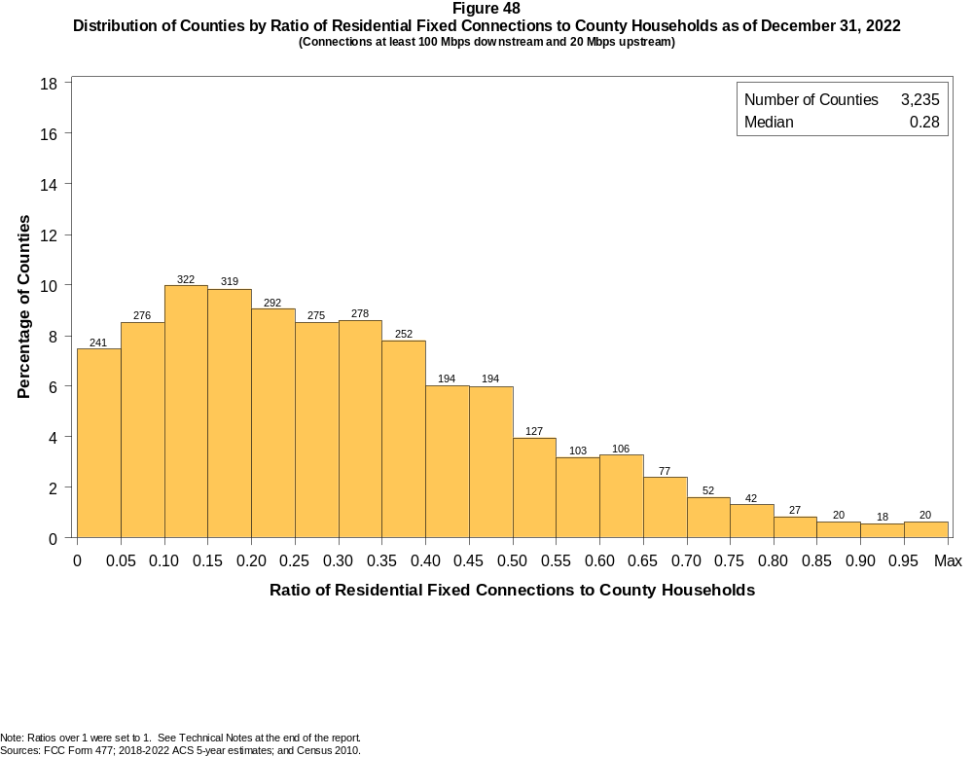

Figure 49
Distribution of Counties by Ratio of Residential Fixed Connections to Households by Technology as of December 31, 2022
(Connections at least 100 Mbps downstream and 20 Mbps upstream)

 | Ratio of Residential Fixed Connections to County Households
Technology | Zero | > 0.00  and  ≤ 0.05 | > 0.05  and  ≤ 0.10 | > 0.10  and  ≤ 0.20 | > 0.20  and  ≤ 0.30 | > 0.30  and  ≤ 0.40 | > 0.40  and  ≤ 0.50 | > 0.50  and  ≤ 0.60 | > 0.60  and  ≤ 0.80 | > 0.80  and  ≤ 1.00 | > 1.00
Total | 1.4 | 6.0 | 8.5 | 19.8 | 17.5 | 16.4 | 12.0 | 7.1 | 8.6 | 2.1 | 0.5
Copper Wire¹ | 59.2 | 34.5 | 3.8 | 2.3 | 0.1 | 0.0 | 0.0 | 0.1 | 0.0 | 0.0 | 0.0
Coaxial Cable | 15.5 | 11.7 | 16.4 | 24.8 | 16.0 | 9.1 | 3.8 | 1.3 | 1.1 | 0.1 | 0.1
Optical Carrier | 8.7 | 34.2 | 13.7 | 18.1 | 9.4 | 6.1 | 4.1 | 1.9 | 2.3 | 1.3 | 0.2
Satellite | 99.2 | 0.8 | 0.0 | 0.0 | 0.0 | 0.0 | 0.0 | 0.0 | 0.0 | 0.0 | 0.0
Fixed Wireless | 41.9 | 57.1 | 0.7 | 0.2 | 0.1 | 0.0 | 0.0 | 0.0 | 0.0 | 0.0 | 0.0
Licensed | 54.1 | 45.5 | 0.3 | 0.1 | 0.0 | 0.0 | 0.0 | 0.0 | 0.0 | 0.0 | 0.0
Unlicensed | 68.4 | 31.0 | 0.4 | 0.2 | 0.0 | 0.0 | 0.0 | 0.0 | 0.0 | 0.0 | 0.0
¹ Other is summarized with Copper Wire for confidentiality reasons.
Note: Each cell indicates the share of 3,235 counties where the ratio of residential fixed connections to households falls within the given range. Numbers may not sum to totals due to rounding.
Sources: FCC Form 477; 2018-2022 ACS 5-year estimates; and Census 2010.

Figure 50
Distribution of Counties by Ratio of Residential Fixed Connections to Households by State as of December 31, 2022
(Connections at least 100 Mbps downstream and 20 Mbps upstream)

 |  | Ratio of Residential Fixed Connections to County Households
State | Counties | Zero | > 0.00  and  ≤ 0.05 | > 0.05  and  ≤ 0.10 | > 0.10  and  ≤ 0.20 | > 0.20  and  ≤ 0.30 | > 0.30  and  ≤ 0.40 | > 0.40  and  ≤ 0.50 | > 0.50  and  ≤ 0.60 | > 0.60  and  ≤ 0.80 | > 0.80  and  ≤ 1.00 | > 1.00
Alabama | 67 | 1 | 8 | 12 | 11 | 14 | 10 | 8 | 2 | 1 | 0 | 0
Alaska | 30 | 8 | 3 | 4 | 2 | 3 | 2 | 2 | 3 | 3 | 0 | 0
American Samoa | 5 | 5 | 0 | 0 | 0 | 0 | 0 | 0 | 0 | 0 | 0 | 0
Arizona | 15 | 0 | 3 | 0 | 2 | 4 | 1 | 5 | 0 | 0 | 0 | 0
Arkansas | 75 | 0 | 7 | 6 | 11 | 17 | 18 | 6 | 2 | 6 | 2 | 0
California | 58 | 0 | 4 | 5 | 8 | 9 | 20 | 9 | 2 | 0 | 0 | 1
Colorado | 64 | 0 | 11 | 5 | 17 | 10 | 13 | 7 | 1 | 0 | 0 | 0
Connecticut | 9 | 0 | 0 | 0 | 0 | 0 | 1 | 2 | 4 | 2 | 0 | 0
Delaware | 3 | 0 | 0 | 0 | 0 | 0 | 0 | 2 | 0 | 1 | 0 | 0
District of Columbia | 1 | 0 | 0 | 0 | 0 | 0 | 0 | 0 | 1 | 0 | 0 | 0
Florida | 67 | 0 | 7 | 6 | 11 | 7 | 5 | 9 | 13 | 9 | 0 | 0
Georgia | 159 | 5 | 2 | 13 | 29 | 30 | 29 | 24 | 15 | 12 | 0 | 0
Guam | 1 | 0 | 1 | 0 | 0 | 0 | 0 | 0 | 0 | 0 | 0 | 0
Hawaii | 5 | 0 | 0 | 0 | 1 | 0 | 1 | 1 | 2 | 0 | 0 | 0
Idaho | 44 | 3 | 5 | 4 | 8 | 9 | 4 | 7 | 1 | 2 | 1 | 0
Illinois | 102 | 0 | 2 | 3 | 13 | 27 | 29 | 23 | 3 | 2 | 0 | 0
Indiana | 92 | 0 | 2 | 2 | 16 | 16 | 31 | 12 | 10 | 3 | 0 | 0
Iowa | 99 | 0 | 0 | 3 | 6 | 17 | 27 | 20 | 18 | 8 | 0 | 0
Kansas | 105 | 0 | 4 | 11 | 24 | 22 | 15 | 16 | 6 | 7 | 0 | 0
Kentucky | 120 | 0 | 3 | 11 | 23 | 25 | 23 | 14 | 9 | 8 | 4 | 0
Louisiana | 64 | 3 | 7 | 10 | 18 | 7 | 10 | 6 | 3 | 0 | 0 | 0
Maine | 16 | 0 | 0 | 1 | 12 | 1 | 2 | 0 | 0 | 0 | 0 | 0
Maryland | 24 | 0 | 0 | 0 | 0 | 2 | 3 | 3 | 2 | 11 | 3 | 0
Massachusetts | 14 | 0 | 0 | 0 | 0 | 1 | 1 | 1 | 5 | 4 | 0 | 2
Michigan | 83 | 0 | 4 | 18 | 29 | 15 | 12 | 3 | 2 | 0 | 0 | 0
Minnesota | 87 | 0 | 1 | 4 | 12 | 28 | 15 | 13 | 6 | 7 | 1 | 0
Mississippi | 82 | 2 | 9 | 4 | 12 | 10 | 18 | 9 | 6 | 10 | 2 | 0
Missouri | 115 | 0 | 11 | 10 | 31 | 17 | 16 | 8 | 11 | 10 | 1 | 0
Montana | 56 | 1 | 17 | 13 | 9 | 4 | 0 | 1 | 2 | 8 | 1 | 0
Nebraska | 93 | 1 | 10 | 4 | 13 | 19 | 18 | 17 | 7 | 2 | 2 | 0

Figure 50 - Continued
Distribution of Counties by Ratio of Residential Fixed Connections to Households by State as of December 31, 2022
(Connections at least 100 Mbps downstream and 20 Mbps upstream)

 |  | Ratio of Residential Fixed Connections to County Households
State | Counties | Zero | > 0.00  and  ≤ 0.05 | > 0.05  and  ≤ 0.10 | > 0.10  and  ≤ 0.20 | > 0.20  and  ≤ 0.30 | > 0.30  and  ≤ 0.40 | > 0.40  and  ≤ 0.50 | > 0.50  and  ≤ 0.60 | > 0.60  and  ≤ 0.80 | > 0.80  and  ≤ 1.00 | > 1.00
Nevada | 17 | 4 | 1 | 1 | 6 | 3 | 1 | 1 | 0 | 0 | 0 | 0
New Hampshire | 10 | 0 | 0 | 0 | 2 | 0 | 2 | 2 | 1 | 2 | 0 | 1
New Jersey | 21 | 0 | 0 | 0 | 0 | 0 | 1 | 3 | 3 | 11 | 3 | 0
New Mexico | 33 | 0 | 6 | 3 | 9 | 1 | 7 | 0 | 2 | 4 | 1 | 0
New York | 62 | 0 | 0 | 0 | 21 | 19 | 8 | 2 | 0 | 9 | 2 | 1
North Carolina | 100 | 0 | 0 | 7 | 23 | 25 | 20 | 14 | 4 | 6 | 1 | 0
North Dakota | 53 | 0 | 0 | 0 | 0 | 0 | 0 | 0 | 2 | 18 | 28 | 5
Northern Mariana Isl | 4 | 4 | 0 | 0 | 0 | 0 | 0 | 0 | 0 | 0 | 0 | 0
Ohio | 88 | 0 | 3 | 12 | 38 | 13 | 11 | 6 | 4 | 1 | 0 | 0
Oklahoma | 77 | 0 | 3 | 2 | 14 | 17 | 16 | 10 | 3 | 11 | 1 | 0
Oregon | 36 | 0 | 1 | 6 | 12 | 12 | 3 | 2 | 0 | 0 | 0 | 0
Pennsylvania | 67 | 0 | 0 | 1 | 8 | 5 | 11 | 13 | 16 | 13 | 0 | 0
Puerto Rico | 78 | 0 | 13 | 28 | 29 | 7 | 1 | 0 | 0 | 0 | 0 | 0
Rhode Island | 5 | 0 | 0 | 0 | 1 | 0 | 0 | 1 | 2 | 1 | 0 | 0
South Carolina | 46 | 0 | 0 | 6 | 6 | 10 | 5 | 7 | 5 | 4 | 2 | 1
South Dakota | 66 | 0 | 1 | 2 | 15 | 4 | 6 | 7 | 4 | 18 | 9 | 0
Tennessee | 95 | 0 | 0 | 2 | 14 | 18 | 14 | 16 | 11 | 17 | 1 | 2
Texas | 254 | 6 | 17 | 28 | 56 | 43 | 36 | 31 | 16 | 20 | 1 | 0
Utah | 29 | 0 | 1 | 1 | 2 | 5 | 5 | 4 | 3 | 5 | 2 | 1
Vermont | 14 | 0 | 0 | 0 | 4 | 2 | 2 | 3 | 1 | 1 | 0 | 1
Virgin Islands | 3 | 0 | 0 | 1 | 2 | 0 | 0 | 0 | 0 | 0 | 0 | 0
Virginia | 133 | 0 | 11 | 6 | 13 | 25 | 25 | 23 | 13 | 15 | 1 | 1
Washington | 39 | 0 | 3 | 3 | 10 | 9 | 10 | 1 | 2 | 1 | 0 | 0
West Virginia | 55 | 3 | 11 | 3 | 7 | 9 | 7 | 12 | 0 | 3 | 0 | 0
Wisconsin | 72 | 0 | 3 | 9 | 21 | 24 | 11 | 1 | 2 | 1 | 0 | 0
Wyoming | 23 | 0 | 0 | 6 | 10 | 2 | 4 | 1 | 0 | 0 | 0 | 0
Total | 3,235 | 46 | 195 | 276 | 641 | 567 | 530 | 388 | 230 | 277 | 69 | 16
Note: Numbers may not sum to totals due to rounding.
Sources: FCC Form 477; 2018-2022 ACS 5-year estimates; and Census 2010.

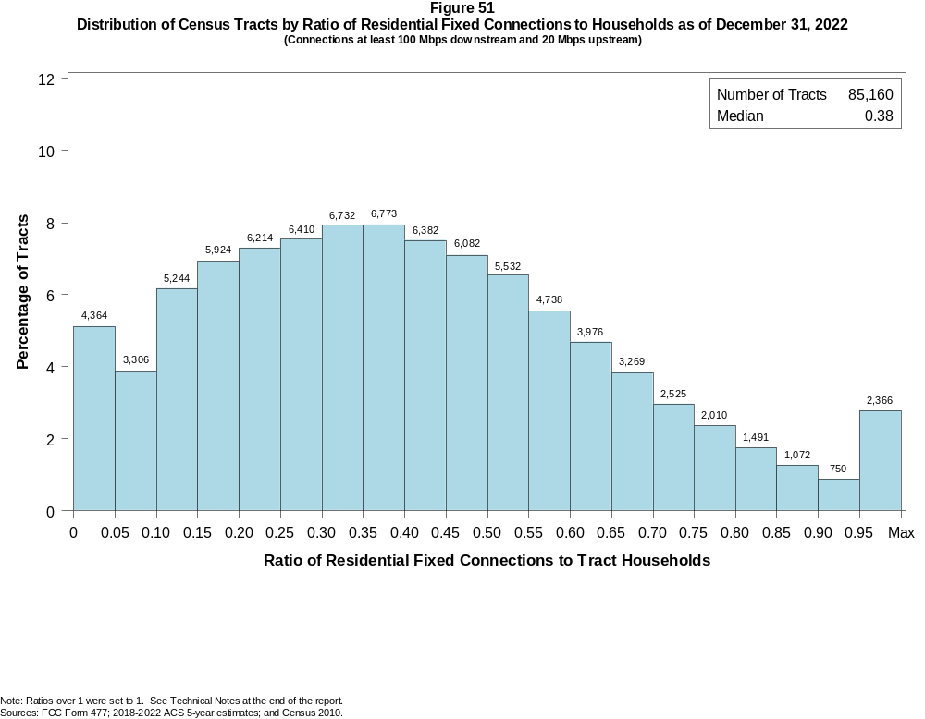

Figure 52
Distribution of Census Tracts by Ratio of Residential Fixed Connections to Households by Technology as of December 31, 2022
(Connections at least 100 Mbps downstream and 20 Mbps upstream)

 | Ratio of Residential Fixed Connections to Tract Households
Technology | Zero | > 0.00  and  ≤ 0.05 | > 0.05  and  ≤ 0.10 | > 0.10  and  ≤ 0.20 | > 0.20  and  ≤ 0.30 | > 0.30  and  ≤ 0.40 | > 0.40  and  ≤ 0.50 | > 0.50  and  ≤ 0.60 | > 0.60  and  ≤ 0.80 | > 0.80  and  ≤ 1.00 | > 1.00
Total | 2.1 | 3.0 | 3.9 | 13.1 | 14.8 | 15.9 | 14.6 | 12.1 | 13.8 | 4.5 | 2.2
Copper Wire¹ | 62.2 | 34.9 | 2.1 | 0.6 | 0.0 | 0.0 | 0.0 | 0.0 | 0.0 | 0.0 | 0.0
Coaxial Cable | 6.2 | 5.1 | 8.2 | 26.9 | 25.6 | 14.6 | 6.6 | 3.1 | 2.6 | 0.6 | 0.4
Optical Carrier | 25.9 | 18.6 | 9.8 | 14.8 | 11.0 | 7.7 | 5.0 | 2.9 | 2.7 | 1.0 | 0.6
Satellite | 100.0 | 0.0 | 0.0 | 0.0 | 0.0 | 0.0 | 0.0 | 0.0 | 0.0 | 0.0 | 0.0
Fixed Wireless | 49.6 | 48.8 | 1.0 | 0.3 | 0.1 | 0.0 | 0.0 | 0.0 | 0.0 | 0.0 | 0.0
Licensed | 52.8 | 46.4 | 0.6 | 0.1 | 0.0 | 0.0 | 0.0 | 0.0 | 0.0 | 0.0 | 0.0
Unlicensed | 93.8 | 5.6 | 0.3 | 0.2 | 0.1 | 0.0 | 0.0 | 0.0 | 0.0 | 0.0 | 0.0
¹ Other is summarized with Copper Wire for confidentiality reasons.
Note: Each cell indicates the share of 85,160 Census Tracts where the ratio of residential fixed connections to households falls within the given range. Numbers may not sum to totals due to rounding.
Sources: FCC Form 477; 2018-2022 ACS 5-year estimates; and Census 2010.

Figure 53
Distribution of Census Tracts by Ratio of Residential Fixed Connections to Households by State as of December 31, 2022
(Connections at least 100 Mbps downstream and 20 Mbps upstream)

 |  | Ratio of Residential Fixed Connections to Tract Households
State | Tracts | Zero | > 0.00  and  ≤ 0.05 | > 0.05  and  ≤ 0.10 | > 0.10  and  ≤ 0.20 | > 0.20  and  ≤ 0.30 | > 0.30  and  ≤ 0.40 | > 0.40  and  ≤ 0.50 | > 0.50  and  ≤ 0.60 | > 0.60  and  ≤ 0.80 | > 0.80  and  ≤ 1.00 | > 1.00
Alabama | 1,435 | 41 | 86 | 102 | 218 | 279 | 194 | 184 | 129 | 143 | 42 | 17
Alaska | 177 | 26 | 18 | 7 | 7 | 5 | 19 | 17 | 31 | 37 | 5 | 5
American Samoa | 18 | 18 | 0 | 0 | 0 | 0 | 0 | 0 | 0 | 0 | 0 | 0
Arizona | 1,765 | 134 | 72 | 151 | 452 | 384 | 219 | 135 | 88 | 86 | 30 | 14
Arkansas | 823 | 23 | 64 | 82 | 138 | 131 | 108 | 93 | 71 | 86 | 22 | 5
California | 9,107 | 127 | 181 | 133 | 811 | 1,829 | 2,217 | 1,803 | 1,164 | 700 | 86 | 56
Colorado | 1,447 | 33 | 73 | 35 | 167 | 311 | 383 | 253 | 106 | 61 | 18 | 7
Connecticut | 879 | 6 | 1 | 0 | 52 | 117 | 112 | 132 | 151 | 210 | 90 | 8
Delaware | 259 | 3 | 0 | 1 | 6 | 23 | 55 | 42 | 47 | 52 | 13 | 17
District of Columbia | 206 | 2 | 0 | 0 | 2 | 11 | 38 | 40 | 40 | 53 | 8 | 12
Florida | 5,114 | 77 | 98 | 96 | 405 | 612 | 824 | 865 | 798 | 805 | 302 | 232
Georgia | 2,791 | 28 | 46 | 93 | 246 | 311 | 408 | 431 | 416 | 607 | 173 | 32
Guam | 56 | 18 | 35 | 1 | 1 | 0 | 0 | 0 | 0 | 0 | 0 | 1
Hawaii | 436 | 14 | 1 | 2 | 16 | 58 | 82 | 78 | 74 | 70 | 18 | 23
Idaho | 456 | 16 | 33 | 19 | 36 | 38 | 43 | 79 | 84 | 78 | 21 | 9
Illinois | 3,263 | 16 | 55 | 47 | 270 | 655 | 851 | 683 | 423 | 233 | 25 | 5
Indiana | 1,693 | 15 | 32 | 56 | 192 | 280 | 403 | 329 | 197 | 148 | 33 | 8
Iowa | 896 | 5 | 17 | 39 | 78 | 90 | 100 | 142 | 157 | 212 | 52 | 4
Kansas | 829 | 24 | 36 | 115 | 118 | 101 | 94 | 68 | 65 | 142 | 50 | 16
Kentucky | 1,306 | 24 | 48 | 87 | 204 | 191 | 218 | 179 | 147 | 168 | 27 | 13
Louisiana | 1,376 | 96 | 88 | 153 | 280 | 189 | 208 | 148 | 105 | 92 | 13 | 4
Maine | 400 | 3 | 18 | 41 | 221 | 67 | 16 | 17 | 5 | 5 | 4 | 3
Maryland | 1,463 | 7 | 7 | 5 | 27 | 95 | 177 | 222 | 225 | 419 | 178 | 101
Massachusetts | 1,613 | 21 | 2 | 8 | 120 | 106 | 181 | 277 | 330 | 398 | 105 | 65
Michigan | 2,971 | 94 | 92 | 151 | 551 | 594 | 658 | 536 | 207 | 70 | 15 | 3
Minnesota | 1,502 | 10 | 47 | 66 | 292 | 422 | 242 | 164 | 96 | 122 | 36 | 5
Mississippi | 875 | 28 | 64 | 37 | 113 | 113 | 104 | 105 | 88 | 155 | 52 | 16
Missouri | 1,654 | 30 | 120 | 85 | 179 | 210 | 274 | 226 | 212 | 237 | 57 | 24
Montana | 319 | 25 | 53 | 41 | 104 | 52 | 9 | 8 | 7 | 16 | 3 | 1
Nebraska | 553 | 3 | 20 | 39 | 98 | 117 | 74 | 71 | 65 | 58 | 6 | 2

Figure 53 - Continued
Distribution of Census Tracts by Ratio of Residential Fixed Connections to Tract Households by State as of December 31, 2022
(Connections at least 100 Mbps downstream and 20 Mbps upstream)

 |  | Ratio of Residential Fixed Connections to Tract Households
State | Tracts | Zero | > 0.00  and  ≤ 0.05 | > 0.05  and  ≤ 0.10 | > 0.10  and  ≤ 0.20 | > 0.20  and  ≤ 0.30 | > 0.30  and  ≤ 0.40 | > 0.40  and  ≤ 0.50 | > 0.50  and  ≤ 0.60 | > 0.60  and  ≤ 0.80 | > 0.80  and  ≤ 1.00 | > 1.00
Nevada | 775 | 20 | 19 | 34 | 216 | 219 | 119 | 64 | 34 | 30 | 11 | 9
New Hampshire | 349 | 3 | 4 | 7 | 25 | 19 | 41 | 68 | 92 | 48 | 18 | 24
New Jersey | 2,175 | 13 | 12 | 5 | 16 | 63 | 121 | 241 | 441 | 812 | 290 | 161
New Mexico | 612 | 52 | 55 | 58 | 252 | 83 | 48 | 23 | 15 | 18 | 6 | 2
New York | 5,393 | 141 | 19 | 102 | 898 | 447 | 434 | 492 | 757 | 1,361 | 510 | 232
North Carolina | 2,660 | 32 | 67 | 104 | 473 | 412 | 398 | 329 | 267 | 348 | 136 | 94
North Dakota | 228 | 1 | 0 | 0 | 0 | 0 | 2 | 7 | 20 | 82 | 94 | 22
Northern Mariana Isl | 23 | 23 | 0 | 0 | 0 | 0 | 0 | 0 | 0 | 0 | 0 | 0
Ohio | 3,162 | 16 | 83 | 227 | 783 | 470 | 459 | 418 | 355 | 259 | 77 | 15
Oklahoma | 1,205 | 37 | 66 | 76 | 204 | 229 | 201 | 142 | 96 | 104 | 41 | 9
Oregon | 994 | 13 | 26 | 42 | 207 | 249 | 181 | 161 | 78 | 28 | 6 | 3
Pennsylvania | 3,445 | 50 | 35 | 55 | 182 | 274 | 468 | 679 | 539 | 757 | 291 | 115
Puerto Rico | 939 | 52 | 165 | 234 | 279 | 134 | 44 | 12 | 12 | 3 | 2 | 2
Rhode Island | 247 | 1 | 1 | 2 | 23 | 9 | 32 | 77 | 46 | 40 | 10 | 6
South Carolina | 1,317 | 20 | 44 | 78 | 189 | 185 | 194 | 158 | 148 | 155 | 79 | 67
South Dakota | 242 | 0 | 7 | 4 | 27 | 16 | 14 | 11 | 21 | 79 | 52 | 11
Tennessee | 1,701 | 29 | 26 | 40 | 209 | 268 | 258 | 257 | 236 | 281 | 74 | 23
Texas | 6,883 | 128 | 220 | 252 | 749 | 730 | 921 | 1,024 | 970 | 1,262 | 428 | 199
Utah | 716 | 9 | 8 | 15 | 57 | 106 | 144 | 132 | 83 | 111 | 35 | 16
Vermont | 193 | 4 | 12 | 8 | 25 | 27 | 44 | 19 | 17 | 23 | 6 | 8
Virgin Islands | 29 | 0 | 2 | 12 | 11 | 4 | 0 | 0 | 0 | 0 | 0 | 0
Virginia | 2,186 | 72 | 84 | 36 | 232 | 287 | 261 | 318 | 272 | 353 | 173 | 98
Washington | 1,772 | 32 | 73 | 48 | 201 | 475 | 470 | 281 | 112 | 64 | 10 | 6
West Virginia | 546 | 48 | 49 | 23 | 49 | 65 | 96 | 86 | 63 | 63 | 4 | 0
Wisconsin | 1,526 | 9 | 97 | 137 | 382 | 430 | 231 | 130 | 66 | 34 | 4 | 6
Wyoming | 160 | 1 | 10 | 15 | 75 | 32 | 13 | 8 | 2 | 2 | 2 | 0
Total | 85,160 | 1,773 | 2,591 | 3,306 | 11,168 | 12,624 | 13,505 | 12,464 | 10,270 | 11,780 | 3,843 | 1,836
Note: Numbers may not sum to totals due to rounding.
Sources: FCC Form 477; 2018-2022 ACS 5-year estimates; and Census 2010.

